AmericanLifelinesAlliance

A public-private partnership to reduce risk for utility and transportation systems in natural hazards

Guidelines for Implementing Performance Assessments of
Water Systems
Volume I
November 2005

Table of Contents
List of Tables iv
List of Figures iv
Acknowledgements v
1.0 INTRODUCTION 1
1.1 Overview of the General Risk Management Decision Process 2
1.2 Hazards Considered 3
1.3 System Performance Metrics. 4
1.4 Multiple Levels of Analysis 5
1.5 Decisions Under Both Risk and Uncertainty 6
1.6 Limitations and Qualifications 6
2.0 OVERVIEW OF THE SYSTEM ASSESSMENT PROCESS 8
2.1 Inquiries 10
2.2 Defining the System 11
2.3 Methods of Analysis 11
3.0 Phase 1–Screening for Significant Hazards and
Susceptibility to Damage or Disruption 13
3.1 Natural Hazard Screening Tools 13
3.2 Component Susceptibility Screening 16
3.3 Transition to Phase 2 Evaluation 16
4.0 Phase 2–Recommended Steps for Phase 2 Analysis 19
4.1 Selecting Phase 2 Analysis Level Based upon Systematic Scoring Criteria 19
4.2 Determining Operational Criticality Rating 21
4.2.1 System Importance Rating (SR) 21
4.2.2 Usage Importance Rating (UR) 22
4.3 Considerations for Modifying the Level of Analysis 24
4.4 Recommended Tasks in Performing Level 1 through Level 3 Analyses 27
4.5 Factoring in Cost and Schedule 28
4.6 Dealing with Multiple Hazards 28
4.7 Defining and Evaluating Human Threats 29
5.0 Acronyms 43
Appendix A: Natural Hazard Phase 1 Screening Maps 44
Appendix B: Examples 51

List of Tables
Table 1-1. Common Important Water System Components and Facilities 3
Table 2-1. Measures of System Performance Associated with Desired Outcomes 5
Table 3-1. Criteria Used in Establishing Relative Hazard Levels 14
Table 3-2. Degree of Component Vulnerability to Damage or Disruption from
Natural Hazards and Human Threats 18
Table 4-1. Selection of Appropriate Levels of Analysis 24
Table 4-2. Sample Inquiries and Suggested Levels of Analysis for Hazards (H),
Vulnerability (V), and System (S) Evaluations 25
Table 4-4. Component Evaluation Matrix for Water systems - Natural Hazards 36
Table 4-6. Hazard Evaluation Matrix for Water systems – Human Threats 39
Table 4-7. Component Evaluation Matrix for Water systems – Human Threats 40

List of Figures
Figure 1-1 Decision-making Process for Assuring System Performance Goals Are Met 7
Figure 2-1. Basic Roadmap for System Performance Assessment 8
Figure 4-1. Range of Effort Needed to Perform Hazard, Vulnerability, and
System Assessments at Different Levels 42

Acknowledgements
The American Lifelines Alliance (ALA) was formed in 1998 under a cooperative agreement between the American Society of Civil Engineers (ASCE) and the Federal Emergency Management Agency (FEMA). In 2001, ALA requested Natural Hazards Management, Inc. to develop guidelines for assisting water utility decision-makers establish performance objectives for their water systems subjected to natural hazards. Following subsequent development of similar ALA guidance documents for other lifeline systems for both natural and human hazards, substantial revision of the guidelines prepared by Natural Hazards Management, Inc. was undertaken by ALA. These revisions incorporated human hazards and adaptations of some components of guidance for non-water systems developed through more recent ALA guidelines projects.

The following people (with their affiliations) contributed to the original report upon which this Commentary is based:
Project Team
Craig Taylor Natural Hazards Management Inc.; Torrance, CA
LeVal Lund Consultant, Los Angeles, CA
John Wiggins J. H Wiggins Company, Redondo Beach, CA
William Graf URS Corporation, Los Angeles, CA
Timothy Volz URS Corporation, Colorado Springs, CO
Danna Judish URS Corporation, Colorado Springs, CO
Garry Lay URS Corporation, Los Angeles, CA
Advisory Committee
Aziz Alfi Seattle Department of Public Utilities, Seattle, WA
Chuck Call Salt Lake Dept. of Public Utilities, Salt Lake City, UT
Bill Nabak Green Bay Water Utility, Green Bay, WI
Dave Putnam Metropolitan Water District of Southern California, Fontana, CA
Robert Gordon Hillsborough County Public Works Department, Tampa, FL
ALA Oversight Committee
Douglas G. Honegger D.G. Honegger Consulting, Arroyo Grande, California
Thomas McLane American Society of Civil Engineers (1998-2001)
Stuart Nishenko Pacific Gas and Electric Company, San Francisco California
William U. Savage U. S. Geological Survey, Menlo Park, California
Joseph Steller National Institute of Building Sciences, Washington D.C.

INTRODUCTION
Assessing the performance of water systems in natural hazard or human threat events is a critical component in prioritizing hazards, understanding the benefits of implementing system improvements, and formulating comprehensive strategies for risk management. The level of effort required to implement a performance assessment is highly variable and depends upon many factors. Some of the most important factors include the following:
- Issues or concerns to be addressed
- Level of detail required in defining performance
- Quality of information available to define relevant hazards
- Level of understanding of system component response to relevant hazards
- Tools available to assess the impact of compromised system components on system performance.
- Constraints on schedule or budget for performing the assessment
The goal of this Guideline is to assist water system owners and operators in defining what approaches are necessary to characterize the anticipated performance of their systems and provide a defensible basis for risk management decisions. Implementation of the approaches recommended in this Guideline will allow these owners and operators to define the scope of activities necessary to determine appropriate risk management actions to reduce the impact of natural hazards and human threat events on water systems to acceptable levels.
The Guideline is written primarily for water utility personnel in management, operations, engineering, maintenance, public information, risk management, and data processing. Regulatory officials, government agencies, industry groups, professional organizations, research organizations, academia, and consulting engineers may also find the Guideline useful.
The application of the assessment process requires various levels of expertise and specialization depending on the topic and the level of assessment required for implementation. For relatively straightforward, lower level approaches, many organizations will be able to conduct the assessment with their own engineering and operations personnel. Special cases, particularly those related to infrequent risks, may require the participation of outside technical specialists. Examples of such cases might include special security problems dealing with human threats, assessing vulnerabilities to critical facilities from unexpected hazards (e.g., newly discovered earthquake faults), or attempting to balance efforts for multiple hazards under a utility-wide risk reduction plan.
The Guideline is organized into the following major sections:
- An overview of the system assessment process and procedures that help to define the appropriate scope of an assessment (Section 2);
- Details on the Phase 1 or screening phase of the assessment (Section 3);
- Details on performing a Phase 2 assessment at varying levels of detail (Level 1, 2 or 3) (Section 4);
- National hazard maps for earthquake, landslide, hurricane wind and tornado, tornado only, riverine and coastal flooding hazards, and ice load hazards (Appendix A); and
- Examples that illustrate the application of the methodology described in the prior sections (Appendix B);
- A commentary that provides background information and resources to facilitate the use of the Guideline (Commentary).
The Guideline and Commentary contain a considerable amount of information that can be used to establish the appropriate scope of a performance assessment. Some users may choose to concentrate on the “big picture” by focusing on the overall process and how the various steps fit together. Others, particularly those with more specialized technical backgrounds, may be more interested in the details of the process. A typical approach to implementation would be to form a team of internal experts to adapt the assessment process to a specific system or facility. Collectively, this team should have specific knowledge about 1) the operations of the system, 2) past history of hazard incidents or events, and 3) system design.

1.1 Overview of the General Risk Management Decision Process
The impact of hazards on water systems over the past several decades is well chronicled, mainly due to the damage to lifelines in the 1971 San Fernando, California. To mitigate unplanned service disruptions and to guard against threats to public safety, leading water utilities have adopted a wide range of strategies to improve critical facilities resistance to these events and enable rapid service restoration if disruption occurs.
The need to assess the performance of any utility system is usually initiated by an inquiry—i.e., a question or request for information, which can be generated either internally or externally. To be responsive, the scope of the assessment must fully recognize the nature of the inquiry because the inquiry is the very essence of why an assessment is needed. The level of detail required in the assessment can also vary significantly depending who is generating the inquiry.
Figure 1-1 outlines a process for decision making that will assure acceptable system performance. The flowchart is not unique to a particular water utility. Instead, it simply summarizes well-tested assessment procedures currently in practice. It begins by identifying the inquiry, or the basic reason for performing the assessment. The inquiry determines the part of the system that is being considered (e.g., a single subsystem or the whole system) and explicitly or implicitly identifies the assessment metric and performance target. For example, a water distribution system in a large urban area might be required to maintain certain pressure minimums outside the immediate area of earthquake damage to prevent service disruption to the entire distribution network.
Identifying hazards, assessing vulnerability of water system components, and assessing the resulting system performance are critical in the overall performance assessment process. These steps represent the essence of this Guideline. The remaining steps in Figure 1-1 are decision-making steps that compare the results of the system performance assessment to the performance target. The scope of the inquiry and the results of the performance assessment will determine whether the performance is deemed acceptable or the system needs to be modified to meet the performance goal. Changes may include system-response or component-response modifications or adjustments to the performance goal.
This Guideline is designed to accommodate decisions based upon assessments that are (a) scenario-based (called deterministic) or (b) risk-based (called probabilistic). Scenario-based methods rely on the evaluation of a water system subjected to a small number of natural hazard scenarios. These, for instance, could include the repetition of past floods, hurricanes, severe rains, earthquakes, and so on. Alternatively hazard events could be modeled to accommodate the latest scientific and engineering knowledge of the hazards. Familiar versions of cost-benefit and related financial methods typically require a risk-based approach.

1.2 Hazards Considered
This guidelines covers the following natural hazards: earthquakes, floods, windstorm (including hurricane and tornado), and ground movements (landslide, frost heave, and settlement). By implication, liquefaction, tsunamis, and seiche are covered as these hazards are usually generated by earthquakes.
As a result of the September 11, 2001 terrorist attacks, security measures have been greatly heightened for water systems. As an example, Public Law 107-188 amended Title XIV of the Safe Drinking Water Act to require all water utilities serving over 3,300 people to complete security vulnerability assessments and provide a plan to address the findings of these assessments.
This Guideline covers water system components and facilities insofar as they are operationally important. Table 1-1 provides a summary of the most common components and facilities included in a water system performance assessment.
Table 1-1. Common Important Water System Components and Facilities
Transmission | Distribution | Facilities | Key Components
Pipelines | Distribution Pipelines | Treatment Plants | Aboveground Storage Tanks
Canals | Service Laterals | Pump Stations | Buried Storage Tanks
Tunnels | Hydrant Laterals | Wells | Pressure Vessels
 |  | Diversion Structures | Piping
Buildings and other water facilities are covered only insofar as they play key roles in water utility operations. These guidelines are not designed to replace building code requirements. Conversely, because water utility components are elements within systems, it is assumed that directly adopting building code requirements for non-building components in water utility systems may not be necessary nor desirable.

1.3 System Performance Metrics.
For evaluating risk and decision alternatives, water utility managers may use a variety of metrics but the selected metric will be dictated by the nature of the inquiry. However, the most common metrics will be welfare metrics. Very typically, these will be of the following forms:
Metric (target): Z% of C served in W days with raw water with adequate fire flow pressures
Metric (target): X% of C served in Y days with fully treated water
In these generalized forms, “C” can stand for the entire system, or for selected stakeholders within the system. Examples of stakeholders include residential customers, emergency operations centers, hospitals, manufacturers, industrial zones, hotels and motels, nursing homes, and so on. These metrics could be measured alternatively in terms of number of service connections, populations served, or volume of water served (i.e., cubic feet or gallons).
In the above forms, one can use existing financial and economic data to convert such metrics into dollar terms. These would include water utility revenues lost, business interruption losses, and other higher order effects of such financial and productivity losses.
One can also add probabilities to the above metrics. For instance, instead of a target of X% of C served in Y days with fully treated water, one may use a more complex target such as “With a probability of P, X% of C served in Y days with fully treated water.” From a practical standpoint, deciding in advance of a water system evaluation how reliable the water system should be is likely to be short-sighted, especially if costs are high to achieve the initial level of reliability. The acceptability of the initial reliability target may well change as one considers existing technologies to reduce risks and who pays for their incorporation into the system.
In addition to the system performance metrics discussed above, water system performance during natural hazards or human threat events is also typically judged according to a set of desired outcomes or performance targets. Although performance targets may vary somewhat, depending on the system or the nature of the hazard, the most important are:
- Protect public and utility personnel safety,
- Maintain system reliability,
- Prevent monetary loss, and
- Prevent environmental damage.
Several different metrics can be used to quantify system performance relative to desired outcomes as illustrated in Table 1-2. Linking performance metrics to desired outcomes is important because it generally influences the choice of measurement methods for quantification. Some performance metrics might require specialized methods, while others may simply make use of field information or expert opinion.
The entries in the columns of Table 1-2 relate the direct measures of system performance to desired outcomes. For instance, “Casualties” and “Hazardous Materials Spillage” are shown as the performance metrics for the desired outcome of “Protect public and utility personnel safety.” In other words, to protect the safety of the public and the utility employees, casualties and hazardous material spillage must be avoided. Note that there are also indirect consequences of an unfavorable outcome that are not indicated in Table 2-1. These indirect consequences can be significant, perhaps even greater than direct consequences. For example, the financial burden placed on an electric power utility to settle liability claims or to provide for environmental cleanup in the event of a hazardous materials spill would qualify as an indirect consequence and could be costly.
Table 2-1. Measures of System Performance Associated with Desired Outcomes
Desired Outcomes (Performance Targets) | Measures of System Performance
Desired Outcomes (Performance Targets) | Capital Losses ($) | Revenue Losses ($) | Service Disruption  (% service population) | Downtime (hours) | Casualties (deaths, injuries) | Lost Product
Maintain system reliability |  |  | X | X
Protect public and utility personnel safety |  |  |  |  | X | X
Prevent monetary loss | X | X | X | X |  | X
Prevent environmental damage |  |  |  |  |  | X

A system performance analysis should consider those principal components of a water system that are important in achieving various desired outcomes (see Table 1-1). Most major components should be included in a performance assessment directed at safety, system reliability, and prevention of monetary loss. Assessments directed at preventing environmental damage should focus mainly on components and systems related to the containment of hazardous materials, system control (shutdown and isolation) and emergency response (maintenance and equipment).

1.4 Multiple Levels of Analysis
This Guideline is based upon a phased approach to assessing system performance. Initial assessments rely largely upon judgments regarding hazard severity, system vulnerability, and system response. As needed, subsequent phases of the assessment process rely increasingly upon more quantitative definitions of hazard, vulnerability and response that necessarily require more detailed information and more analytically complex assessment methods.
As elaborated in subsequent chapters, the basic iterative steps in a water system performance assessment evaluation consist of inventorying pertinent water system components, defining hazard events and their consequences, evaluating the response of water system components to these hazards, and evaluating the system response to damages to the water utility components (see shaded steps in Figure 1-1).

1.5 Decisions Under Both Risk and Uncertainty
The goal of an evaluation of a water system subjected to natural hazards and human threat events is to develop systematic information for a decision both under risk and uncertainty. That portion of a decision based upon the synthesized information from such an evaluation may be called a portion of the decision under risk. In a decision under risk, there is still an element of chance, but this is quantified through the risk evaluation process. In contrast, decisions under uncertainty—in their extreme form—do not have relevant information. Virtually all methods identified in this Guideline suffer from varying levels of uncertainty that can not be removed. An evaluation of a water system subjected to a variety of hazard events thus produces estimates that will be limited in their accuracy.

1.6 Limitations and Qualifications
The Guideline is not a design manual, standard, or code. Although effort has been taken to define the methodology and to develop example applications, this guideline has not undergone the rigorous process of consensus validation and revision or widespread pilot testing in the industry. The content does, nevertheless, represent the current standard of practice in assessing the performance of electric power systems in natural hazards and human threat events. The procedures presented herein are considered appropriate for implementation, but are subject to revision when improved methods become available, particularly for the assessment of human threats.
Because the goal of this guideline is to reach a wide range of users, a multilevel approach has been developed. This approach includes procedures ranging from simple ones that can be applied in a few days to more comprehensive ones that require weeks to months to complete. The Guideline is structured so that both small and large utilities can carry out assessments that are appropriate to the inquiries they receive.
The Guideline does not address interdependency issues that may involve other risks for the utility, especially dependency conditions on other lifelines.
Finally, this guideline should be viewed as a “living” document. As new data, information, and methods become available, the procedures in this document need to be reviewed and modified to reflect current thinking on acceptable approaches for hazard, vulnerability, and system performance assessments. In this regard, the Commentary, which contains a listing of applicable methods of analysis, becomes a key component of the Guideline and should also be updated as new material becomes available.

Figure 1-1 Decision-making Process for Assuring System Performance Goals Are Met

2.0 OVERVIEW OF THE SYSTEM ASSESSMENT PROCESS
Before responding to a particular inquiry, it is useful to view the entire assessment process. The flowchart in Figure 2-1 provides a roadmap that lays out the major phases of the assessment, key decision points for expanding the assessment to a more detailed level, and consideration of cost and schedule constraints. The process in Figure 2-1 is illustrated as being sequential. In practice, however, the process may be cyclic, requiring several iterations to determine the appropriate level of analysis. The process, whether sequential or cyclic, basically remains the same:
• Screen the hazard severity and assess the generic vulnerability of the system to that hazard to determine the need for a more detailed evaluation;
• Ensure that adequate resources and expertise are available to perform the evaluation; and
• Determine the appropriate level of analysis based upon the inquiry and available resources and schedule.

Figure 2-1. Basic Roadmap for System Performance Assessment
The second step in the flowchart calls for a Phase 1 screening evaluation (see Section 3.0). A Phase I screening assessment is intended to eliminate from consideration those hazards or water system components with the following characteristics:
- There are no significant hazards affecting the component or system based upon the severity of the hazard or the likelihood of the hazard occurring
- The component or the system as a whole is not susceptible to damage or failure if subjected to the hazard(s) under consideration.
Only those hazards that can not be dismissed as insignificant and components that are susceptible to damage are considered in subsequent refined assessment activities performed as Phase 2 of the assessment process.
If no significant hazard or risk of damage from the hazard exists, then the analysis process can be terminated. For example, some areas of the U.S. are not subject to damaging earthquakes, and as such, pipelines in those areas are not at significant risk of damage from earthquake-induced ground failure. Similarly, Gulf of Mexico coastal areas are subject to hurricane force winds, but buried pipelines essentially have no risk from damaging wind.
If the inquiry is not satisfied by a Phase 1 evaluation or the system is determined to be susceptible to damage or loss of function for the hazard under evaluation, a Phase 2 evaluation is necessary. The Phase 2 evaluation can be performed at several levels of sophistication. As a result, the process in Figure 2-1 may be repetitive if the initial Phase 2 evaluation is not adequate to address the inquiry. Phase 2 evaluations should be undertaken as a progressive, multilevel sequence of tasks, relatively simple at the lowest level and increasing in detail with each higher level. Tasks performed at lower analysis levels become part of the next higher level. Data and information collected in each lower level task are used, as applicable, at higher levels. In practice, organizations of all sizes and types use some form of this progressive, multilevel analysis process. The Guidelines define three levels of effort for a Phase 2 performance assessment, Level 1 through Level 3.
- Level 1 is designed to provide a simplified estimate of hazard, vulnerability, or system performance. This analysis can usually be completed within a matter of days and, in most cases, can be completed by operations and engineering staff. The results are considered uncertain by a factor of 2 to 3 or more and may be used to scope out the extent of the problem in order to decide whether more detailed studies are needed. If the results from this level of analysis do not satisfy the inquiry, then a higher level of analysis should be used (Level 2).
- Level 2 is characterized as an intermediate and more quantitative analysis, which often depends on historical or statistical information to quantify hazard, vulnerability, and system performance, and involves collecting data from the field. Level 2 is typically completed within a matter of weeks rather than months or years and can be performed by operations and engineering staff with assistance as needed from external technical specialists. The accuracy of the results is better than approximate, often providing quantitative results within a factor of 2 or 3. If further detail or precision is required, then a Level 3 analysis is recommended.
- Level 3 represents the highest level of analysis. It is detailed and quantitative with results accurate to the state-of-the-practice. This level is characterized by more accurate and more complete data, the use of more advanced methods (e.g., proprietary software), and will generally require the participation of external technical specialists. Level 3 analyses often require extensive fieldwork, laboratory tests, and generally take months or even years to complete.
In general, employing three levels of analysis promotes the most efficient use of resources. By planning more broadly from the beginning (Level 1) and then ramping up to more detailed evaluations as needed (Levels 2 and 3), the use of a utility’s resources can be more effectively prioritized and optimized. Another advantage of using a multilevel analysis approach is that it extends the applicability of the Guideline to the broadest possible range of power utility companies and the performance-related inquiries they face by avoiding the ”one size fits all” approach.
The scope for the Phase 2 evaluation should contain an appropriate level of detail and take into account cost and schedule constraints (see Section 4 for guidance on determining the appropriate level of analysis).
Once the analysis level has been determined, a step-by-step list of the needed tasks should be compiled (see Section 4.3). The task list is similar to a scope of work in a Request for Proposal. The scope of work may be performed within the normal activity of a utility operations or engineering department or may be more involved and require the participation of additional technical specialists with extensive background and experience.

2.1 Inquiries
This section introduces the concept of an inquiry generated by either an internal source (e.g., water utility board requesting a briefing on the assets at risk from a particular hazard) or an external inquiry (e.g., a regulatory body requesting actions be taken to assure the reliability of service to customers in the event of a major natural disaster or human threat event). The nature of the inquiry plays an important role in defining the scope of a performance assessment. The level of detail required to answer the inquiry will vary depending on a number of factors, including whether it is externally or internally generated. While each water utility system has its own unique features, there are certain common elements among such systems that can serve as a baseline for defining the tasks required to assess system performance.
In some instances, an actual event or incident may prompt an assessment from internal and external sources simultaneously. For example, an earthquake that caused damage to some part of a system not previously known to be vulnerable might prompt internal and external inquires to determine if the damage was associated with an isolated incident or an indication of a wider problem.
Because inquiries can come from a variety of sources inside or outside water utilities, the effort to develop a response can range from a matter of a few hours to a significant commitment of resources. It is impossible to come up with a list of inquiries for every conceivable situation. The following list of inquiries is representative.
The nature and type of inquiry will influence, to a large degree, the recommended level of analysis. Although there are no specific rules that define the levels of analysis for specific inquiries, experience suggests that there are practical levels of analysis for certain general conditions and situations.

2.2 Defining the System
The components to be included in the analysis depend in large part on the inquiry and the performance target being investigated. For example, in the case of a customer approaching a water utility about the reliability of the system to deliver water to its facility following a major earthquake, the water utility must decide which components should be assessed. Reliability in this scenario is measured by service disruption and downtime. The water utility would identify critical components of the water system involved in providing water to the customer meter or service connection.
Examples of the types of information that are typically needed include the following:
- Facility design drawings, specifications and reports,
- Soils and geological reports for buildings, reservoirs and pump stations,
- Water service transmission and distribution piping maps, GIS, and water system analysis models,
- Equipment lists,
- Pressure zone maps,
- Critical customer lists,
- Water consumption records,
- Emergency response or contingency plans,
- Hazardous Materials Risk Management Prevention Plans or similar studies,
Depending upon the focus of the inquiry, replacement values for the buildings, other structures and equipment at the utilities facilities may be required.

2.3 Methods of Analysis
In practice, the analysis methods can vary depending on the types of data available, regional characteristics or practices, resources available (time, staff, and budget), background and experience of the analysts, the nature of the estimate, and the accuracy required.
Although there may be a myriad of acceptable analytical methods, the Guideline emphasizes those believed to be the most practical for application by water utility companies. Specific techniques, procedures, and practices have been identified for use in estimating such parameters as earthquake ground motions, hurricane wind speeds, equipment fragility, and, more broadly, system performance. The use of some of these methods requires specialized background and training. The intent is to provide the user with a broad view of available methods with respect to the overall assessment process without being exhaustive or excluding new or developing techniques.
For a Level I effort, geologic hazards, weather-related hazards and other natural hazards can be adequately defined based upon published geologic mapping, perhaps with limited field reconnaissance. A geographic information system (GIS) representation of the agency’s transmission piping may allow digitally available mapping information to be overlaid on a map of the agency’s facilities to provide preliminary analysis of likely natural hazard conditions. The GIS model also allows piping damage rates to be tallied subject to various geologic conditions, such as landslides, ground movements from freeze/thaw, or seismic hazards. Seismic hazards such as liquefaction and landslide may be examined, using published earthquake hazard zone maps to show how much of the system may be affected, and to assist in scoping further geologic investigations to assess the spatial variation of the hazard severity.
By using three levels of analysis, the performance assessment can be tailored to the content of the inquiry (the level of detail required to appropriately characterize the hazard, vulnerability, and system performance) and to the source of the inquiry (the appropriate level of detail needed for the regulatory agency, government, investment entities, insurers, customers, the public, or the management of the water utility or pipeline operating company). In other words, different types of inquiries lead to different levels of assessment depending on their source, the context in which the inquiry is being made, and the underlying considerations for hazard, vulnerability and system performance.
The recommended level of analysis in Phase 2 is based upon a qualitative rating system that assigns a numerical score based upon the operational criticality of the system under consideration, the level of hazard, and the vulnerability of system components.

3.0 Phase 1–Screening for Significant Hazards and Susceptibility to Damage or Disruption
As noted in Section 2.3, the purpose of a Phase 1 evaluation (introduced in Section 3.1) is to screen out a component or system evaluation if any of the following conditions are met:
- There are no significant hazards affecting the component or system, or
- The component or the system as a whole is not susceptible to damage or failure if subjected to the hazard(s) under consideration.
A system may be subjected to some hazard types, but not necessarily to all hazard types. Similarly, a system may be susceptible to damage or failure from some hazards, but not necessarily from all hazards.
Recommendations for assessing the vulnerability to human threats since the terrorist attacks of September 11, 2001 have adopted an approach that assumes the potential for extreme human threats has been treated as ever-present (total certainty of human threat occurrence). Consequently, it is suggested that Phase 1 screening should not rule out human threats on the basis of not being present or not capable of causing damage. Therefore, for the assessment of human threat events, Phase 1 screening could be bypassed in favor of proceeding directly to Phase 2.

3.1 Natural Hazard Screening Tools
Natural hazards are identified as “local” and “regional” hazards. Local hazards are ones that can be characterized only by conducting fieldwork or by using microzonation maps (when available). This Guideline defines local hazards as riverine flooding, landslides, surface fault rupture, liquefaction, and settlement. Regional hazards, which can be depicted on a national or state map, include earthquake ground shaking, severe winds (including extreme winds, hurricane and tornado), coastal flooding, and icing. Hence, the distinction between local and regional hazards is important because of the relative spatial accuracy of the information portrayed for each.
The Guideline uses national maps to characterize Phase 1 hazard levels for earthquake, landslide, severe wind (hurricane and tornado), riverine and coastal flooding, and icing. For hazards that are considered local (e.g., flooding and landslides), the information on these maps is approximate and quite conservative in the sense that the presence of local hazards within a jurisdiction causes the entire jurisdiction to be classified according to the severity of the local hazard itself. A county, for example, could be classified as high risk for landslides because a relatively small portion of the county land area is situated on unstable slopes. Or, it could be considered hazardous for flooding with only a small area within an active floodplain. Therefore, it should be recognized that local hazards have a site-specific aspect that must be taken into account. Considering the qualitative and approximate nature of Phase 1 screening, this does not cause an undue hindrance.
Table 3-1 summarizes the criteria used to establish low, medium, and high hazard levels for earthquake, landslide, wind, tornado, icing, flooding, and human threats. The values in Table 3-1 are considered to represent reasonable separation points or boundaries. Additional discussion of the range boundaries is provided in Section 3 of the Commentary.
Table 3-1. Criteria Used in Establishing Relative Hazard Levels
Hazard Level | Earthquake | Landslide | Wind | Tornado | Icing | Flooding | Human Threats
Low | Peak Ground Acceleration (PGA) < 0.15 g | Low incidence | Not high or medium | < 5 tornadoes per 10,000 sq. mi. | ≤ 0.25 in. | Q3 data not available for the county | DHS Threat Advisory Green
Medium | 0.15 g ≤ PGA  ≤ 0.5 g | Moderate Incidence or moderate susceptibility/ low incidence | Wind speed > 90 mph, but < 120 mph | 5 to 25 tornadoes per 10,000 sq. mi. | Greater than 0.25 in. and less than 1.0 in. | Q3 data available for the county | DHS Threat Advisory Blue (Guarded) to Yellow (Elevated)
High | PGA > 0.5 g | High incidence or high susceptibility/ moderate incidence or high susceptibility/ low incidence | Wind speed ≥ 120 mph, or Gulf/Atlantic county whose basic wind speed is 110 mph or greater, or Hawaii | > 25 tornadoes per 10,000 sq. mi. | ≥ 1.0 in. | Q3 data available for the county | DHS Threat Advisory Orange (High) to Red (Severe)
Note: The digital Q3 Flood Data published by FEMA are designed to provide guidance and a general proximity of the location of Special Flood Hazard Areas. The digital Q3 Flood Data cannot be used to determine absolute delineation of flood risk boundaries, but instead should be seen as portraying zones of uncertainty and possible risks associated with flood inundation.
Hazard level maps for earthquake, landslide, severe wind (hurricane and tornado), tornado only, riverine and coastal flooding, and icing are contained in Appendix A. Each map is derived from a federal or state database. The information contained in each map is also available digitally, which makes the use of these maps very compatible with a “look-up” procedure. A comprehensive tabular listing of natural hazard levels by county is provided in the Commentary.
The most significant hazards in Table 3-1 for water systems are earthquake, including various types of earthquake-induced ground failure and flooding. Landslides and flooding can also cause damage to water system components, but to a lesser degree because of the limited portion of the system components typically exposed to these hazards in any one hazard event, the possible exception being extreme flooding events that may result in damage over a multi-state area. Insignificant hazards conspicuous enough to have become the subject of an inquiry will typically be eliminated from consideration in the Phase 1 screening.
Information on other time-dependent, weather-related natural hazards, such as wildfire and flooding, can be obtained through federal websites that have seasonal or more frequent updates—e.g., http://drought.unl.edu/dm, USGS/NWS flood advisories, and so forth.
The time-dependent nature of human threat levels has been considered in developing the separation points for human threats in Table 3-1. The hazard level criteria in particular are based upon the five-color Department of Homeland Security (DHS) threat assessment levels, which were developed after the terrorist attacks on September 11, 2001. The high hazard level is based upon the Orange (High) and Red (Severe) threat assessment levels and the existence of specific, credible information about a human threat against the water utility industry. More industry-specific information on human threat levels can be obtained from the water Information Sharing and Analysis Cener (ISAC) at www.waterisac.org. The medium hazard level is based upon the Blue (Guarded) and Yellow (Elevated) threat assessment levels and nonspecific, general information about the potential for a human-caused disruption of service. The low hazard level is based upon the Green (Low) threat assessment level and the existence of no known threats to the electric power industry other than normal human threats, such as vandalism. The threat assessment level has not fallen below Yellow (Elevated) since September 11, 2001.
When using national hazard maps with this guideline, the user should bear in mind several cautions:
- The “county level” for data mapping is used because it represents a reasonable and convenient geographic unit to map data (hazards) on a national level. The county level works better in states with smaller counties, which generally means areas east of the Rocky Mountains. The limitations of using county-level maps to portray local hazards must be fully recognized, as discussed earlier in this section.
- When using maps for characterization of hazards at the national or local level, the choices of separation points for low, medium, and high hazards must be established consistent with the underlying basis for the selected map. For example, the use of the earthquake hazard maps produced by the U.S. Geological Survey for the United States and its territories are associated with 2, 5, and 10 percent probabilities of exceeding the mapped ground-motion values in 50 years. Naturally, the ground-motion values on these maps increase with the decreasing probability of exceedance. Current national standards, such as ASCE 7 (ASCE, 2005) and NFPA 5000 (2005), use ground-motion criteria based upon a 2 percent probability of exceedance in 50 years. Water utilities may elect to base Phase 1 screening and the determination of analysis levels upon different probabilities of exceedance. The methodology provided in the Guideline should accommodate the various types of maps with their associated probabilities of exceedance, but due consideration should be given to the choice of appropriate criteria separation points for low, medium, and high hazard levels.
- ASCE-7 identifies special wind zones that require site-specific input from local building jurisdictions (local maps typically delineating special wind hazard areas). Such areas do not exist unless the wind hazard is significant; therefore, the existence of “special” wind zones is probably sufficient evidence to indicate a need for a Phase 2 evaluation.
- Some caution should be exercised in the interpretation of flood hazard levels from the map provided in the Appendix. The low level separation point for the flooding hazard in Table 4-1 is keyed to the existence of Q3 maps (FEMA 1996, 2003a). If a Q3 map is not available, then the hazard is assumed to be generally low. However, if a “local” flood hazard is known to exist for the area of consideration despite the absence of a Q3 map, then the assessment should be upgraded to a Phase 2 evaluation.

3.2 Component Susceptibility Screening
The second stage of the Phase 1 screening process addresses component vulnerability. Table 3-2 provides qualitative information, based upon judgment from experienced practitioners, on the vulnerability of key water system components. The table is intended to serve as a general guide for typical components and noncritical components. Special circumstances may exist that would cause a particular component, facility, or system to be more or less vulnerable than indicated in Table 3-2. In the case of components or systems that are critical to overall system operations, it may be prudent to skip this screening step and proceed directly to a Phase 2 assessment. For example, if the consequence of failure from a critical component is high (e.g., it impacts a sizable portion of the service population or impacts service to major customers), then a Phase 2 assessment is recommended.
The entries in Table 3-2 identify the general degrees to which water system components are potentially vulnerable to the hazards and threats described in this guideline. The entries are either in the form of an unqualified “H”, “M”, or “L” (high, moderate, or low) or may include consideration of conditions or situations under which a particular component may be vulnerable. Usually these distinctions consider whether or not a component is located above or below the ground. In general, belowground components tend to be vulnerable to permanent ground movement hazards (surface fault rupture, liquefaction, landslide, frost heave, and settlement). Aboveground components will be affected more by earthquake ground shaking, flooding, wind, icing, and other collateral hazards (fire, dam inundation, collapses of nearby structures, and some human threats such as blasts). The absence of an entry in a particular cell indicates that the corresponding component is not likely to be susceptible to damage or disruption regardless of what hazard level is expected. The entries in Table 3-2 assume that the component is of recent vintage, i.e., post 1945. If the component being evaluated is older than this, it may be more susceptible to damage. In these cases, the original design may not have accounted for some of these hazard types. In such situations, a Phase 2 evaluation is appropriate.
The user will also have to make a choice on what vulnerability level to select for an analysis that includes multiple components or facilities. In these cases, the Guideline recommends that all components that should be a part of an assessment be evaluated and the highest level of vulnerability for the group be used to define the level of analysis.

3.3 Transition to Phase 2 Evaluation
Even though the results from Phase 1 suggest otherwise, there may be several reasons to proceed to a Phase 2 evaluation. Some of these reasons include:
- A quantitative response to an inquiry is deemed preferable to a qualitative response.
- A known localized hazard exists that is not identified by national-level hazard maps,
- The hazard under assessment is a human threat.
- There are known incidents or failures that suggest a higher level of vulnerability than is implied by Table 3-2.
- The component under assessment is extremely critical to system operations.
- Maintaining service is vital to national security.
As a general rule, if eliminating any subsequent studies (based upon the results of the Phase 1 evaluation) appears questionable, the user should proceed to Phase 2. The most adverse result from this decision is that a Level 1 analysis is performed.

Table 3-2. Degree of Component Vulnerability to Damage or Disruption from Natural Hazards and Human Threats
HAZARDS | COMPONENT
HAZARDS | Wells | Canals | Tunnels | Transmission Pipelines | Distribution Pipelines | Service Laterals | Aboveground Storage Tanks | Buried Storage Tanks | Treatment Facilities | Diversion Structures | Pump Stations | Electronic and Computer Equipment for SCADA, Operations, and Business Functions⁽³⁾ | General Office, Maintenance, and Operations, Buildings and Their Equipment
Natural Hazards
Earthquake Shaking | L | L | L | ─ | L | L | H | M | M | M | M | M | M
Ground Displacements⁽⁴⁾ | H | H | H | H | H | H | H | H | H | H | H | ─ | H
Flooding⁽⁵⁾ | M | H | ─ | L | L | L | M | M | H | H | H | H | L
Severe Wind⁽⁶⁾ | ─ | ─ | ─ | ─ | ─ | ─ | M | ─ | M | L | M | H | ─
Icing | ─ | L | ─ | ─ | ─ | ─ | L | ─ | L | L | L | L | ─
Human Threats
Physical Attack⁽⁷⁾ | H | M | M | M | M | M | H | M | H | H | H | H | H
Biological/Chemical/Radiological Attack | M | M | L | M | M | M | L | L | M | L | L | L | M
Cyber Attack | ─ | ─ | ─ | ─ | ─ | ─ | ─ | ─ | ─ | ─ | ─ | H | M
NOTES:
- Degrees of vulnerability: H = high, M = Moderate, L = Low
- Entries assume that the components are of recent vintage (i.e., post 1945) see sec 3.2
- When a component or system is located within a building, the vulnerability of both the building and component should be considered (e.g., equipment considered at risk if there is a potential for building collapse or evacuation)
- Includes ground displacement from landslide, frost heave, and settlement and earthquake-induced displacement such as fault rupture, liquefaction, lateral spread displacement, and settlement
- Includes riverine flooding, storm surge, tsunami, and seiche
- Includes extreme wind storms, hurricane, and tornado
- Includes armed intrusion and sabotage

4.0 Phase 2–Recommended Steps for Phase 2 Analysis
For those components and systems found to be at risk in the Phase 1 screening, a Phase 2 analysis is recommended. This section introduces scoring criteria used to initiate a Phase 2 evaluation. Selection of a Level 1, Level 2, or Level 3 analysis for Phase 2 depends on factors such as the scope of the inquiry, hazard level, vulnerability level, nature of consequence, and system redundancy level.
Conducting a Phase 2 analysis generally results in some quantitative outcome, which is valuable because the performance can be assessed in terms of the metrics of performance in Table 2-1. For this reason, Phase 2 analyses are particularly useful in hazard reduction programs where the benefits and costs of mitigation can be compared directly.
Determining the appropriate level for the performance analysis is integral to Phase 2. To facilitate this decision, a set of scoring criteria is employed to determine an appropriate level of analysis based upon hazard, vulnerability, and system information. This section also provides guidance on how to modify these determinations using information from the inquiry itself. A long list of inquiries serves as examples for these modifications.
The detailed tables at the end of the section identify specific tasks that should be considered under each level of analysis. Examples of the recommended types of analysis can also be found in the Commentary.

4.1 Selecting Phase 2 Analysis Level Based upon Systematic Scoring Criteria
Individuals with requisite experience in risk assessment can often intuitively select the appropriate analysis levels for the hazard, vulnerability, and system performance. As an alternative to such experience and intuition, a systematic scoring procedure for determining a baseline level of analysis has been developed specifically for this Guideline. The resulting baseline from scoring can be adjusted upward or downward for particular analysis elements depending on the type of inquiry, budget and schedule constraints, and consideration of specific performance measures.
Hazards include natural hazards and human threats, such as:
– Earthquakes
– Flooding
– Windstorms, including hurricanes and tornados
– Icing
– Ground displacements, including landslides, frost heave, and settlement
– Physical Attack (including armed assault and sabotage)
– Biological threats
– Chemical threats
– Radiological threats
– Blast
– Cyber attacks
Vulnerability includes the potential for physical damage and loss of life with respect to:
– Physical facilities
– Functional systems
– Environment
– Administrative/financial activities
– Human safety
System Performance includes the consequences resulting from system damage or disruption as measured by:
– Capital and revenue losses
– Service disruption and downtime (e.g., days to provide raw water service with adequate fire flow pressures, days to provide fully treated water)
– Casualties
– Hazardous materials release and environmental damage
System performance is characterized using an Operational Criticality rating that defines both system importance (SR) and usage importance (UR) elements.
The major elements of a Phase 2 performance assessment are definition of the hazard (H), determination of component vulnerability (V), and assessment of system performance (S). A performance assessment involves the selection of an appropriate level of analysis within each of the three elements. In aggregate, they constitute an appropriate approach for responding to an inquiry. For example, the recommended approach for an inquiry may call for a simplified hazard analysis (Hazard analysis–Level 1), a moderately detailed analysis of component fragility (Vulnerability analysis–Level 2), and a simplified (qualitative) systems analysis (System Performance analysis–Level 1). The primary emphasis in this example is on component performance with a secondary concern on how this performance will affect the overall operation of the system. In the Guideline, the above analysis is simply denoted as an H1-V2-S1 analysis. Examples of hazard, vulnerability, and system performance analysis levels for specific inquiries are discussed in Section 4.2.
The scoring system provides a systematic and objective process for determining an overall or baseline level of analysis for performance assessments. It is assumed that a Phase 1 screening has been completed (see Section 3) and that cases associated with no hazard or no vulnerability have been eliminated from consideration. The scoring system accounts for the:
- Severity of the hazard,
- Vulnerability of the system or component,
- Damage consequences, including life safety, financial loss, disruption of service, and environmental and other impacts,
- Size of the system.
The first step in the scoring process is to compute an overall rating index for the performance assessment. It is defined as the product of individual severity indices for hazard, vulnerability, and consequence of damage. The index is compared to defined ranges that suggest the overall analysis level, either Level 1, Level 2, or Level 3. This evaluation must be conducted on a hazard-by-hazard basis; that is, there is no attempt at integrating the results from different hazards.
The level index R is defined as the product of H, V, and the operational criticality rating (OCR).
R = H x V x OCR (4-1)
where,
H = hazard score (Low = 1, Medium = 2, High = 3 as defined in Table 3-1)
V = vulnerability score (Low = 1, Moderate = 2, High = 3 as defined in Table 3-2)
OCR = operational criticality rating as defined in Section 4.2

4.2 Determining Operational Criticality Rating
The operational criticality rating (OCR) in Equation 4-1 relates the importance of the system or component relative to the consequences of damage including, loss of service, loss of flow capacity, offsite damage (e.g., flooding), and indirect effects (e.g., lack of water for fire fighting). Determining the OCR is intended to rely on judgment and therefore requires input from persons with the requisite operational knowledge.
The OCR combines a system importance rating (SR) and a usage importance rating (UR) with the relative importance between system importance and usage importance defined by relative importance factors f_{s} and f_{u}, respectively.
(4-2)
where:
SR = system importance rating (integer value of 1 to 5)
UR = usage importance rating (integer value of 1 to 5)
f_{s} = importance of system performance relative to usage (0 to 1.0)
f_{u} = importance of usage relative to system performance (0 to 1.0)
f_{s} + f_{u} = 1.0
The relative importance factors are judgmental weights. Note that the definitions of the relative importance factors requires that these factors have values between 0 and 1 with the sum of the factors equal to 1. As an example, values of f_{s} = 0.67 and f_{u} = 0.33 would stress the operational importance of maintaining the integrity of the system relative to the importance of the service provided.

4.2.1 System Importance Rating (SR)
The system importance rating (SR) is ranges from 5 (highly significant with respect to system operation) to 1 (insignificant with respect to system operation).
The SR for a reservoir may be rated in accordance with the capacity range criteria below (rating numbers are provided as an example only):
5 – 2,500,000 gallons or greater
4 – 1,800,000 to 2,500,000 gallons
3 – 1,300,000 to 1,800,000 gallons
2 – 750,000 to 1,300,000 gallons
1 – Less than 750,000 gallons
The SR for a pump station may be rated in accordance with the following ranges for the capacity of the station (rating numbers are provided as an example only)
5 – Greater than 10,000 gpm
4 – 5,000 to 10,000 gpm
3 – 2,500 to 5,000 gpm
2 – 1,000 to 2,500 gpm
1 – Less than 1,000 gpm
Similarly, for other components, SR is qualitatively based upon relative water throughput.

4.2.2 Usage Importance Rating (UR)
The usage importance rating (UR) combines four ratings:
PR = importance of providing potable water (integer value of 1 to 5)
FR = importance of providing water for fire fighting (integer value of 1 to 5)
LR = importance of preventing life-safety hazards (integer value of 1 to 5)
The value of UR is based upon combination of the above ratings in a manner that considers their relative importance:
(4-3)
where:
f_{p} = relative importance of potable water (0 to 1.0)
f_{f} = relative importance of fire-fighting water (0 to 1.0)
f_{l} = relative importance of life-safety hazards (0 to 1.0)
f_{p} + f_{f} + f_{l} = 1.0
An example of how individually criticality ratings might be developed is as follows:
PR – Potable Water Rating
5 – System supplies more than 80% of total potable water
4 – System supplies less than 80% of total potable water
3 – System supplies less than 50% of total potable water
2 – System supplies less than 20% of total potable water
1 – System supplies less than 5% of total potable water
FR – Fire Flow Rating
5 – System required for 100% of hydrant service following earthquake
4 – System required for 70% of hydrant service following earthquake
3 – System required for 30% of hydrant service following earthquake
2 – System required for 10% of hydrant service following earthquake
1 – System not required for immediate fire flow supply
LR – Life Safety Rating
5 – Hazardous materials quantities sufficient for significant off-site consequences
4 – Hazardous materials quantities insufficient for significant off-site consequences
3 – Personnel occupying parts of the system more than 75% of the time
2 – Personnel occupying parts of the system less than 75% of the time
1 – Personnel occupying parts of the system less than 20% of the time
The above are only examples of how a rating system may be developed. Rating systems should be developed on a case-by-case basis considering the nature of the inquiry, system components being considered, the type of service provided (e.g., wholesale vs. distribution), public sentiment, and utility management priorities and commitments.
As an example, consider the rating that might be applied to a transmission pipeline that is the only source of potable water to two 1 million gallon storage tanks owned by a community water distribution company. Since there are no personnel “occupying” the pipeline and the fire flow for the community is provided by the local storage and distribution system, FR and LR are assigned values of 1.0. Since the transmission pipeline is the only source of potable water to the community, PR is assigned a value of 5. The value of UR is 5 based upon a value of 1.0 for f_{p}. The value of SR is taken to be 4 based upon the 2 million gallons of storage provided by the transmission pipeline. In determining the OCR, the value of f_{s} is taken to be 0.7, indicating that more weight is given to the integrity of the pipeline compared to the usage of the water. The value of f_{f} becomes 0.3. Therefore value of the OCR is
An integer value of 4 for the OCR is used in combination with the hazard and vulnerability ratings in Equation (4-1).
The second and final step of the scoring process is to compare the performance rating, R, to a set of preset range cutoffs that define a recommended baseline level for the performance assessment. Based upon all possible permutations of input parameters, the level index may range in value from 1 to 45. The baseline level for the performance assessment is determined by the ranges in Table 4-1.
As mentioned earlier, the baseline level represents a starting point for establishing the level of analysis. Analysis levels might require upward or downward adjustment depending upon the type and source of the inquiry (see Section 4.2).

Table 4-1. Selection of Appropriate Levels of Analysis
Level Rating (R) | Baseline Level for Performance Assessment
R ≤ 6 | No Assessment
7 ≤ R < 17 | Level 1
17 ≤ R < 35 | Level 2
R ≥ 35 | Level 3

4.3 Considerations for Modifying the Level of Analysis
The scoring system described in the previous section indicates the recommended levels of evaluation based upon hazard information, component vulnerabilities, and the consequences of system failure or disruption. In actual practice, considerations of who is generating the inquiry and what question the inquiry is intended to answer may reduce or expand the levels of evaluation required. Table 4-2 contains numerous sample inquiries and the levels of evaluation that may result when one considers who is asking the question and what is being asked. These sample inquiries are developed to assist in adapting the generic assignments of evaluation level to specific conditions or situations that may be prompted by a particular inquiry or inquirer. The assessment levels associated with the sample inquiries may also be used directly to obtain a preliminary estimate of the likely scope of the assessment. In this table, H, V, and S are defined in terms of the levels of effort required to perform a hazards, vulnerability, or systems evaluation, respectively.
There are three types of cases in Table 4-2 in which the level of assessment determined by the rating system may be modified by considering the source and content of the inquiry.
- The assessment need only provide a general response to an issue even though the framing of the inquiry may suggest a high level of effort. In this case, the assessment level is reduced to what is necessary to satisfy the party making the inquiry.
- The inquiry has the potential to lead to further inquires related to specific regulatory issues or key management decisions. In this case, higher level of analysis than would otherwise be deemed necessary by the scoring system may be desirable to provide information that would help to add specificity to follow-on inquiries.
- The inquiry can be addressed without more detailed analysis of one or more of the assessment components (i.e., hazard, vulnerability, or system response). In these cases, more less detailed analyses are suggested for one or two components in order to more efficiently address the essence of the inquiry.
Table 4-2. Sample Inquiries and Suggested Levels of Analysis for Hazards (H), Vulnerability (V), and System (S) Evaluations
Sample Inquiry Content | Likely  Level  From  Rating | Level of Analysis |  |  | Potential Source and Content Factors
Sample Inquiry Content | Likely  Level  From  Rating | H | V | S | Potential Source and Content Factors
- Inquiry by a regulatory body on general system exposure | 1 | 1 | 1 | 1 | No special factors
- Customer request on reliability of service | 1 | 1 | 1 | 1 | No special factors
- General inquiry by the press or public | 1 | 1 | 1 | 1 | No special factors
- Interaction with professional associations | 1 | 1 | 1 | 1 | No special factors
- Inquiry by a regulatory body on location of a landslide hazard relative to a facility | 1 | 2 | 1 | 1 | H increased based upon perceived follow-on inquiries
- Inquiry by a regulatory body on consequence of a local hazard at a facility | 1 | 1 | 2 | 1 | V increased based upon perceived follow-on inquiries
- Inquiry by a regulatory body on consequence of a local hazard at a critical facility | 3 | 3 | 3 | 1 | S reduced since inquiry focused on single facility
- Inquiry by a regulatory body on detailed evaluation of hazards relative to a cluster of facilities | 3 | 3 | 1 | 1 | V and S reduced because of inquiry focus on hazards
- Inquiry by a regulatory body on detailed evaluation of a hazard relative to a facility | 3 | 3 | 2 | 1 | V and S reduced because of inquiry focus on one hazards at a single facility
- Regulatory body wanting more detailed information on criticality and hazard design parameters | 2 | 2 | 1 | 2 | V reduced since inquiry focused on design, not evaluation of existing components
- New regulation to require a given performance level for specific hazards | 3 | 3 | 3 | 3 | No special factors
- Regulatory body requesting detailed evaluation of potential service losses given specific localized hazards (e.g., landslides) | 2 | 2 | 1 | 3 | S increased and V decreased because of inquiry focus on service losses
- Regulatory body requesting detailed evaluation of potential single-contingency service losses with respect to specific critical facilities | 3 | 3 | 3 | 3 | No special factors
- Regulatory body requesting detailed evaluation of potential service losses given detailed evaluation of localized hazards | 3 | 3 | 1 | 3 | V decreased because of inquiry focus on service losses
- Inquiry to know general information on criticality and detailed information on hazards used in new design | 2 | 3 | 1 | 2 | H increased and V decreased because of inquiry focus on new design for detailed hazard information
- Upper management wanting to know general financial exposure | 1 | 1 | 2 | 1 | V increases because focus is on expected repair and replacement cost forecasts.
- Addressing risk management or insurance issues | 1 | 1 | 2 | 1 | V increased since focus of inquiry is repair and replacement cost forecasts.
- Investor concerns | 2 | 2 | 2 | 2 | No special factors
- Upper management wanting to know general exposure | 2 | 2 | 2 | 2 | No special factors
- Upper management request to identify the most critical facilities relative to mapped localized hazards (e.g., landslides) | 1 | 1 | 1 | 2 | S increased since inquiry is focused on identifying system-critical facilities
- Follow-up request to characterize in greater detail the vulnerabilities of critical facilities | 1 | 1 | 2 | 1 | V increased since inquiry focused on vulnerability of critical facilities
- Determining post-hazard service to critical facilities served (e.g., hospitals) | 2 | 2 | 2 | 3 | S increased since focus of inquiry is service to critical facilities
- Upper management wanting a thorough natural hazards response system emphasizing detailed evaluations of hazards | 3 | 3 | 2 | 3 | V reduced since focus of inquiry is managing the response of the system following natural hazard events
- Upper management wanting a natural hazards risk management system that allays all concerns about due diligence | 3 | 3 | 3 | 3 | No special factors
- Inquiry by the utility’s Board of Directors on a specific hazard concern | 1 | 1 | 1 | 1 | No special factors
- Disaster that causes slightly unexpected damage | 1 | 1 | 1 | 1 | No special factors
- Inquiry on specific hazards leading to unexpected damage having significant system impacts | 2 | 2 | 3 | 2 | V increased since focus of inquiry is unexpected damage

4.4 Recommended Tasks in Performing Level 1 through Level 3 Analyses
Previous sections provide general guidance for determining the level of analysis appropriate for each element of the performance assessment (hazard, component vulnerability, and system performance). The next step in the assessment process identifies the specific tasks required to perform a Level 1 (simplified), Level 2 (intermediate), or Level 3 (detailed) analysis.
Tables 4-3 through 4-8 summarize the recommended tasks for performing analyses for Levels 1 through 3. Tables 4-3 through 4-5 address natural hazards, and Tables 4-6 through 4-8 address human threats. Each set of tables contains a table for quantifying the hazard (Table 4-3 and 4-6), a table for assessing component vulnerability (Table 4-4 and 4-7), and a table for examining system performance (Table 4-5 and 4-8). Specific tasks are identified in each row of the tables, and the diamonds indicate inclusion of the task in one or more levels of analysis. Consistent with the terminology introduced previously, the letters refer to a specific element of the assessment (H refers to hazard; V, vulnerability; and S, system performance) and the number after the letter indicates the level of analysis (e.g., H1 refers to Hazard Level 1).
Tasks at each lower level are typically repeated at higher levels. This is intentional because the details of each subsequent analysis level build on the information and data collected in lower levels. The absence of a diamond in a lower level means there are no simpler ways of conducting that task of the analysis.
The tasks that are reflected in each of the tables are key in defining the precise scope of the assessment. As previously noted, they may be equated to the tasks delineated in a Request for Proposal (RFP). Furthermore, the type of inquiry that initiated the planning of the performance assessment serves to define the overall objective of the assessment. The guidance provided in Section 4.5 helps provide a rough indication of the cost and time required to complete the assessment. In total, the information contained in Tables 4-3 through 4-8 and the discussion in the previous sections should be sufficient for developing a work scope for Phase 2.
Background discussion of methods for conducting individual tasks in Tables 4-3 through 4-8 is included for reference in the Commentary.

4.5 Factoring in Cost and Schedule
Cost and schedule considerations also affect the selection of analysis levels for Phase 2. It is important to develop realistic estimates for the level of effort and resources, including technical expertise, required for an adequate assessment. Figure 4-1 provides estimates of the range of effort generally required for the different elements of a Phase 2 analysis (hazard, vulnerability, and system performance). The level of effort is measured in terms of the number of days, weeks, or months required by the equivalent of an appropriately qualified full-time employee to perform a specific scope of work. For purposes of establishing Figure 4-1, the Guideline assumes that the system under investigation is a larger utility with many sites and components. Smaller utilities, with fewer sites and components, or investigations of isolated parts of the system would require more modest resources.
The estimated levels of effort in Figure 4-1 are intended to serve as general ranges only. The level of effort required to complete these analyses may vary considerably according to the background and experience of the personnel or specialists assigned to the work tasks. Similarly, the completion schedule can vary according to the total resources that can be devoted to the effort.
As shown in Table 4-2 and discussed in Section 4.2, various combinations of hazard (H), vulnerability (V), and system performance (S) analyses are possible. The accuracy and completeness of Phase 2 analyses can vary according to the selection of the individual levels of analysis (i.e., the selected levels of H, V, and S). Generally, the accuracy and completeness of the analyses improve by increasing the resources and time devoted.

4.6 Dealing with Multiple Hazards
Most water systems are exposed to a variety of natural hazards and human threats. This is due in large part to the extended nature of these systems, both geographically and operationally. Therefore, inquiries that relate to prioritization or ranking of risks may often require consideration of multiple hazards.
The ideal assessment process addressing multiple hazards would integrates the results of multiple hazard studies so that the overall risk to the system is minimized. To do so, however, would require that risks be evaluated based upon all contributing hazards with each hazard being evaluated using the same framework (usually probabilistic). Unfortunately, this type of integration, while meaningful, is largely beyond the current state-of-practice.
The rating system presented in the guidelines can be used to determine the tasks necessary to perform assessments for each hazard. Implementing these tasks will generally require some prioritization of the various hazards. It is recommended that a relative prioritization of hazards be based upon the overall rating index for each hazard.
The recommended approach to hazard prioritization still requires an inquiry and the prioritization of hazards may vary significantly with the nature of the inquiry. For example, inquiries related to the reliability of buried transmission pipelines will typically result in high priority given to hazards that include permanent ground movement or loss of pipe support such as landslides, stream scour, and earthquake displacements related to surface faulting and lateral spread movement. Conversely, hazards such has wind, general flooding, icing, and human threats would have a low priority to the same inquiries. The prioritization could be substantially different for an inquiry related to the vulnerability of a computerized customer database for a large water system.
Despite the dependence of the recommended approach to prioritizing efforts, this relative ranking process is commonly used in the evaluation of multiple risks and has been shown to provide an owner a means to identify risks reduction measures while maintaining a feasible work scope.

4.7 Defining and Evaluating Human Threats
The human threat “intensity” must be defined to allow evaluation of the vulnerability of the various system components. There is a range of threat intensities, ranging from vandals to state-sponsored terrorists. It is not feasible to plan to protect against organized and well-financed terrorist attacks that may involve sophisticated weaponry (e.g., missile launchers), require military hardware to defend against (e.g., antiaircraft defenses, radar jamming equipment), or monitoring and defending sites and facilities that are not under the control of the utility (e.g., protecting a large dam that could destroy critical water utility facilities or components if breached). The responsibility for identifying and responding to such extreme threats is properly delegated to state and federal agencies. For the remaining categories of human threats, the utility should develop a design basis human threat considering:

- The number of people likely to participate in the attack
- Their training
- Available equipment
- Available weapons
- Knowledge of the wastewater system
Once this design basis threat has been established, the vulnerability to the system components can be evaluated.
Ideally, the human threat likelihood would be quantified to allow direct comparison with the potential risks from natural hazards. In reality this is not possible given the minimal data available to establish recurrence relationships from historical events and the fact that the nature of human threats is constantly changing. That is, the threat (of terrorism) was different 10 years ago compared to what it is today, and compared to what it will be 10 years from now, with changes in world politics. The real value of quantifying the design basis threat would be to compare the human threat risk against the risk of natural hazards.
The typical approach is to assume that the human threat event will happen (probability equals 100%). This results in a relative risk assessment, and provides no guidance on the relative risk between natural hazards and the human threat.
Another approach is to bound the threat likelihood. That is, to make assumptions based on available information and rational judgment. For example, how many terrorist attacks resulting in system loss of function would the evaluator expect within the next 50 years anywhere within the United States. Consider the number of water utilities of comparable or larger size that constitutes a reasonable target, as well as the other infrastructure systems that may be targets, such as natural gas supply and electric power.
Two of the most common tools used to assist water utilities in assessing potential vulnerabilities to human threats are VSAT™ (Association of Metropolitan Sewerage Agencies, 2003) and RAM-WSM (Sandia National Laboratories, 2001).
The VSAT™ methodology was designed to assist with the identification of security risks posed to critical assets of water systems and to perform benefit-cost analyses of potential mitigation. To compute risk, a system’s critical assets are paired with perceived security threats, and the likelihood and consequences for each pair are assessed. Threat-asset pairs with relatively higher probabilities of occurrence and/or more severe consequences correspond with greater security risks. Cost benefit analyses performed within VSAT™ focuses available resources for security upgrades on the most significant risks.
In response to the Public Health Security and Bioterrorism Preparedness and Response Act of 2002, the RAM-WSM methodology was developed by Sandia National Laboratories to assess human threats for water utilities. This methodology has been broadly utilized and generally accepted and is easily adapted to the assessment of vulnerability of water utilities to human threats.
The RAM-WSM methodology begins with the identification and ranking of critical system facilities using a process termed “pair-wise comparison”. An inventory of critical assets associated with each critical facility is then developed using general system knowledge, or for a more rigorous evaluation, fault tree assessment. Critical assets are the components required for maintaining the functioning of system facilities (the pumps, valves, pipes, electrical equipment, and power supply at a transfer station for example).
The RAM-WSM methodology continues with the application of the risk equation (4-4) to obtain a risk value (R) for each critical asset. The terms of the risk equation are developed as follows:
R = P_{A} * (1-P_{E}) * C (4-4)
where:
- P_{A} is the likelihood of attack – is generally assumed to be 1.0 (100 percent), so the calculation only uses the vulnerability (1-P_{E}) and the consequence parameters, without consideration of the hazard, and therefore the result is the “relative” risk.. Estimating the actual probability of attack to a system would be very difficult. The use of 1.0 carries the assumption that an attack will occur. A design basis threat characterizes the nature of the potential attack, allowing the utility to design its security protection systems to “reasonably and prudently” mitigate such an attack as defined in the regulation. “Reasonably” and “prudently” are qualitative measures of reliability.

- P_{E} is a measure of the assessed effectiveness of a system’s current security protection. Generally, a value of 0.1 to 0.3 would be assigned if security systems in place were judged to have little effectiveness. Higher values are assigned (0.9 typically representing the maximum) for higher levels of effectiveness. P_{E} is determined using a qualitative assessment.

- C is a measure of the consequences of an attack on a critical asset. Consequences are determined based on the impact to the system’s operating objectives. Several objectives may be considered with a low, medium or high consequence assigned for each objective. An overall consequence value derived by this process for each critical asset is utilized in the risk equation.

The RAM-WSM methodology then assesses the relative benefits of proposed security system upgrades in terms of reducing the relative risk. The reductions in relative risk from potential upgrades for both physical protection systems (such as intrusion alarms and upgraded locks) as well as operating systems (development of procedures to respond to a suspected attack) form the basis for a plan for risk reduction.

Table 4-3. Hazard Evaluation Matrix for Water Systems – Natural Hazards
Hazard/Task | Notes | H1 | H2 | H3
1.1 Earthquake Hazard – Surface Fault Rupture
1.1.1 Review active fault hazard mapping for area, if available |  | ◆ | ◆ | ◆
1.1.2 Review topographic maps |  | ◆ | ◆ | ◆
1.1.3 Review stereo aerial photographs, if available | 1 |  | ◆ | ◆
1.1.4 Perform field reconnaissance (by qualified geologist) | 1 |  | ◆ | ◆
1.1.5 Characterize active faults through fault trenching | 1 |  |  | ◆
1.1.6 Estimate fault displacements using empirical methods | 2 |  | ◆ | ◆
1.1.7 Determine fault displacements and their likelihood through fault  trenching, sampling, age dating, and analysis | 2 |  |  | ◆
1.2 Earthquake Hazard – Liquefaction
1.2.1 Review literature on regional seismicity | 3 | ◆ | ◆ | ◆
1.2.2 Perform system-wide probabilistic seismic hazard assessment (PSHA) | 2, 4 |  | ◆ | ◆
1.2.3 Review topographic maps |  | ◆ | ◆ | ◆
1.2.4 Review surface geology maps |  | ◆ | ◆ | ◆
1.2.5 Review available geotechnical data |  | ◆ | ◆ | ◆
1.2.6 Conduct minimal soil borings, standard or cone penetration tests |  |  | ◆
1.2.7 Conduct extensive soil borings, standard and/or cone penetration tests |  |  |  | ◆
1.2.8 Perform field reconnaissance (by qualified geotechnical engineers) |  |  | ◆ | ◆
1.2.9 Identify potentially liquefiable soil deposits by judgment |  | ◆ | ◆ | ◆
- Identify potentially liquefiable soil deposits by engineering analysis of  soils data | 2 |  | ◆ | ◆
1.2.11 Estimate lateral spread displacements using empirical methods | 2 |  | ◆ | ◆
1.2.12 Estimate liquefaction potential using liquefaction susceptibility maps | 2 |  | ◆ | ◆
- Estimate likelihood of liquefaction and extent of lateral spread displacements using analytical tools such as FLAC | 2 |  |  | ◆
1.3 Earthquake Hazard – Strong Ground Shaking
1.3.1 Review literature on regional seismicity | 3 | ◆ | ◆ | ◆
1.3.2 Review seismic hazard mapping for area, if available | 4 | ◆ | ◆ | ◆
1.3.3 Review surface geology maps |  | ◆ | ◆ | ◆
1.3.4 Develop ground motion amplification factors |  |  | ◆ | ◆
1.3.5 Estimate ground motion levels using judgment and existing maps | 2 | ◆ | ◆ | ◆
1.3.6 Estimate ground motion levels using empirical methods | 2 |  | ◆ | ◆
1.3.7 Estimate ground motion levels using analytical methods or tools | 2 |  |  | ◆
1.3.8 Perform system-wide PSHA | 2, 4 |  |  | ◆
1.4 Earthquake Hazard – Landslide
1.4.1 Review surface geology maps |  | ◆ | ◆ | ◆
1.4.2 Review topographic maps |  | ◆ | ◆ | ◆
1.4.3 Review stereo aerial photographs, if available |  |  | ◆ | ◆
1.4.4 Review rainfall maps for area |  | ◆ | ◆ | ◆
1.4.5 Perform field reconnaissance (by qualified geologists) |  |  | ◆ | ◆
1.4.6 Review available ground shaking hazard maps for region | 2, 4 | ◆ | ◆ | ◆
1.4.7 Evaluate landslide potential using expert judgment |  | ◆ | ◆ | ◆
1.4.8 Evaluate landslide potential using slope stability maps |  |  | ◆ | ◆
1.4.9 Evaluate landslide potential using statistical or empirical analysis | 2 |  | ◆ | ◆
1.4.10 Evaluate landslide potential using analytical methods | 2 |  |  | ◆
1.5 Earthquake Hazard –Tsunami
1.5.1 Locate facilities within 10 miles of major water bodies |  | ◆ | ◆ | ◆
1.5.2 Review topographic maps of coastal areas |  | ◆ | ◆ | ◆
1.5.3 Review bathymetric maps of near-shore areas |  |  | ◆ | ◆
1.5.4 Estimate potential tsunami flooding using expert judgment | 2 | ◆ | ◆ | ◆
1.5.5 Estimate potential tsunami flooding using judgment and evaluation of  potential tsunami sources | 2 |  | ◆ | ◆
1.5.6 Perform site-specific inundation analysis | 2 |  |  | ◆
2.1 Ground Deformation Hazard – Landslide (Non-earthquake)
2.1.1 Review surface geology maps |  | ◆ | ◆ | ◆
2.1.2 Review topographic maps |  | ◆ | ◆ | ◆
2.1.3 Review stereo aerial photographs, if available |  |  | ◆ | ◆
2.1.4 Review rainfall maps for area |  | ◆ | ◆ | ◆
2.1.5 Perform field reconnaissance (by qualified geologists) |  |  | ◆ | ◆
2.1.6 Evaluate landslide potential using expert judgment | 2 | ◆ | ◆ | ◆
2.1.7 Evaluate landslide potential using statistical or empirical analysis | 2 |  | ◆ | ◆
2.1.8 Evaluate landslide potential using analytical methods | 2 |  |  | ◆
2.2 Ground Deformation Hazard – Settlement
2.2.1 Review surface geology maps |  | ◆ | ◆ | ◆
2.2.2 Review topographic maps |  | ◆ | ◆ | ◆
2.2.3 Review groundwater maps and available geotechnical reports |  | ◆ | ◆ | ◆
2.2.4 Perform field reconnaissance (by qualified professionals) |  |  | ◆ | ◆
2.2.5 Evaluate settlement potential using expert judgment | 2 | ◆ | ◆ | ◆
2.2.6 Evaluate settlement potential using empirical methods | 2 |  | ◆ | ◆
2.2.7 Evaluate settlement potential using advanced analytical methods | 2 |  |  | ◆
Determine potential for manmade-induced settlement (e.g., groundwater withdrawal) |  | ◆ | ◆ | ◆
2.3 Ground Deformation Hazard – Frost Heave
2.3.1 Review surface geology maps |  | ◆ | ◆ | ◆
2.3.2 Perform field reconnaissance (by qualified geotechnical engineers) |  |  | ◆ | ◆
2.3.3 Review existing soil borings, test pits, and ditch logs, as available |  | ◆ | ◆ | ◆
2.3.4 Conduct limited soil borings |  |  | ◆ | ◆
2.3.5 Conduct extensive soil borings |  |  |  | ◆
2.3.6 Evaluate frost heave potential using expert judgment | 2 | ◆ | ◆ | ◆
2.3.7 Evaluate frost heave potential using empirical methods | 2 |  | ◆ | ◆
2.3.8 Evaluate frost heave potential using advanced analytical methods | 2 |  |  | ◆
3 Wind Hazard
3.1 Review national wind maps (ASCE 7-02) |  | ◆ | ◆ | ◆
3.2 Review literature on local wind history |  | ◆ | ◆ | ◆
3.3 Identify local conditions that may increase wind hazard | 5 |  | ◆ | ◆
3.4 Gather historical storm (hurricane) patterns | 6 |  | ◆ | ◆
3.5 Identify potential wind storms using expert judgment |  | ◆ | ◆ | ◆
3.6 Conduct field evaluations |  |  | ◆ | ◆
3.7 Estimate potential wind hazards using expert judgment |  | ◆ | ◆ | ◆
3.8 Perform system-wide probabilistic wind hazard assessment (PWHA) | 2 |  |  | ◆
4 Icing Hazard
4.1 Review national icing hazard map ASCE 7-02 |  | ◆ | ◆ | ◆
4.2 Review literature on local icing history |  | ◆ | ◆ | ◆
4.3 Identify local conditions that may increase icing hazard |  |  | ◆ | ◆
4.4 Estimate potential icing hazards using expert judgment |  | ◆ | ◆ | ◆
4.5 Perform system-wide probabilistic icing hazard assessment |  |  |  | ◆
5 Flooding Hazard
5.1 Review Q3 digital flood maps and national Flood Insurance Rate Maps | 7 | ◆ | ◆ | ◆
5.3 Gather local flood data from local/regional jurisdiction | 8 | ◆ | ◆ | ◆
5.4 Overlay flood maps onto system maps |  |  | ◆ | ◆
5.5 Collect topographic, stream, rainfall data |  |  | ◆ | ◆
5.6 Identify potential flooding hazard from local dams or floodways |  | ◆ | ◆ | ◆
5.7 Evaluate flooding potential using expert judgment |  | ◆ | ◆ | ◆
5.8 Perform analytical flood hazard analysis (HEC RAS, HAZUS-MH) | 2 |  | ◆ | ◆
Notes
In the three right-hand columns, letters refer to a specific element of the assessment (H refers to hazard; V, vulnerability; and S, system performance) and the number after the letter indicates the level of analysis
1 – Generally applies to western U.S. faults because they tend to be expressed by geologic features near the surface.
2 – See Commentary for list of peer-reviewed methods.
3 – There are numerous sources of information on regional seismicity. Some of these can be viewed on the U.S. Geological Survey (USGS) website (www.usgs.gov).
4 – Probabilistic seismic hazard maps have been prepared for many areas of the U.S. A good source of publicly available maps for the entire U.S. is the USGS website (http://eqhazmaps.usgs.gov).
5 – Some of these factors are terrain, location of nearby urban developments, etc.
6 – Some of this information is contained on the NOAA website (www.noaa.gov).
7 – Flood hazard maps are available on the FEMA website (www.fema.gov/fhm).
8 – Most local jurisdictions have detailed flood maps for their respective areas.

Table 4-4. Component Evaluation Matrix for Water Systems - Natural Hazards
Component/Task | Notes | V1 | V2 | V3
1 Fragility Assessment of Water system Equipment
- Gather information by interviewing utility design engineers, field engineers, and operations managers. Obtain performance assessments (estimates, informed estimates) and any performance data (statistics) that they may be aware of. |  | ◆ | ◆ | ◆
- Gather information by performing site survey(s) to assess local conditions and information on the general vulnerability of components. | 1 |  | ◆ | ◆
- Gather information by performing site survey(s) to assess collateral hazards from off-site sources and nearby structures and equipment. | 2 |  | ◆ | ◆
- Gather information by reviewing drawings and calculations for critical equipment items. |  |  | ◆ | ◆
- Gather information by performing site visits to verify installation details for critical equipment items. | 3 |  | ◆ | ◆
- Perform structural calculations to verify the adequacy of observed installation details for critical equipment items or conformance to performance-based specifications. |  |  |  | ◆
- Assess equipment fragilities using estimates, informed estimates, and experience data from past events (statistics) with minimal field data collection | 4 | ◆ | ◆ | ◆
- Assess equipment fragilities using representative field data from Tasks 1.2 through 1.5 and from more detailed data on shipping loads, equipment qualification, and fragility testing. | 5 |  | ◆ | ◆
- Assess equipment fragility using actual field data (as described in Tasks 1.2 through 1.6) and the results of structural analysis of selected equipment. | 4 |  |  | ◆
2 Fragility Assessment of Critical Buildings
- Gather information by interviewing utility operations managers and building maintenance personnel. |  | ◆ | ◆ | ◆
- Identify critical functions within buildings and the damage that would impair or impede these functions. |  | ◆ | ◆ | ◆
- Perform general site survey(s) to assess local conditions and to collect information on the general vulnerability of buildings, their contents, and any nearby equipment and their supports. | 1 |  | ◆ | ◆
- Perform general site survey(s) to assess collateral hazards from off-site sources and nearby structures and equipment. | 2 |  | ◆ | ◆
2.5 Assess performance of building and support equipment using judgment (estimates or informed estimates) and/or experience (statistical) data from past events or using empirical damage assessments, with minimal field data collection. | 4 | ◆ | ◆ | ◆
2.6 Review architectural and structural drawings, design calculations, foundation evaluation reports, and past structural assessment reports to assess building capacity. |  |  | ◆ | ◆
2.7 Perform independent structural calculations to assess building capacity. | 4 |  | ◆ | ◆
2.8 Develop computer-based structural analysis to assess building response. | 4 |  |  | ◆
Notes
1 – There are several manuals that identify key steps in conducting a site survey (see the Commentary for references). Users should consider, however, whether equipment items are restrained and, if so, how they are restrained.
2 – Key items to note are steep slopes, the locations of large tanks or reservoirs, possible chemical spill sources, and large towers or trees (especially on slopes near ingress and/or egress routes).
3 – It is important to assess whether actual installations are per design (i.e., according to standard procedures).
4 – See the Commentary for examples.
5 – It is important to gather information and data from enough sites so that general installation practices can be assessed.

Table 4-5. System Performance Evaluation Matrix for Water Systems – Natural Hazards
Task | Notes | S1 | S2 | S3
1 System Performance Assessment
1.1 Review system maps |  | ◆ | ◆ | ◆
1.2 Review system performance in past natural hazards/events |  | ◆ | ◆ | ◆
1.3 Develop system model of critical operations |  |  | ◆ | ◆
1.4 Overlay system model onto map of different hazards (GIS function) | 1 |  | ◆ | ◆
1.5 Estimate system performance using expert judgment | 2 | ◆ | ◆ | ◆
1.6 Perform systems analysis for limited scenarios (minimum 3) |  |  | ◆ | ◆
1.7 Perform systems analysis for full probabilistic analysis | 3 |  |  | ◆

Notes
1 – Most utilities are moving towards some type of geographic information system (GIS) to map key system data and information.
2 – One way of examining performance is to create a set of scenarios that can be reviewed by key operations personnel.
3 – See the Commentary for examples.

Table 4-6. Hazard Evaluation Matrix for Water Systems – Human Threats
Hazard/Task | Notes | H1 | H2 | H3
1.1 Hazard Assessment – Biological, Chemical, Radiological and Blast
1.1.1 Collect historic data on incidents and near misses |  | ◆ | ◆ | ◆
1.1.2 Collect historic data on other companies and industrial systems – statistical approach | 1 | ◆ | ◆ | ◆
1.1.3 Review one-call activity reports |  |  | ◆ | ◆
1.1.4 Review third-party activity and incident history reports |  |  | ◆ | ◆
1.1.5 Review federal and state homeland security agency data | 2 | ◆ | ◆ | ◆
1.1.6 Consult with internal experts – expert opinion and estimate | 3 | ◆ | ◆ | ◆
1.1.7 Consult with local law enforcement agencies – expert opinion |  |  | ◆ | ◆
1.1.8 Consult with other utility companies |  |  |  | ◆
1.1.9 Create threat scenarios that can be reviewed with operations personnel | 4 |  |  | ◆
1.2 Hazard Assessment – Cyber
1.2.1 Collect historic data on other companies and industrial systems | 1 | ◆ | ◆ | ◆
1.2.2 Review federal and state homeland security agency data |  | ◆ | ◆ | ◆
1.2.3 Consult with internal experts | 3 | ◆ | ◆ | ◆
1.2.4 Consult with other utility companies security |  |  |  | ◆
1.2.5 Consult with cyber security information technology companies |  |  |  | ◆

Notes
1 – Many of these reports can be obtained from the Federal Energy Regulatory Commission (FERC) or the Department of Homeland Security.
2 – Some agencies that might provide useful data include: Department of Homeland Security – Critical Infrastructure Protection Initiative; Federal Emergency Management Agency; Center for Strategic and International Studies; American Society for Industrial Security, and Rand Corporation.
3 – These would include Director of Security, Chief Information Officer, etc.
4 – This may require the help of experts who deal specifically with these kinds of threats.
Table 4-7. Component Evaluation Matrix for Water Systems – Human Threats
Task | Notes | V1 | V2 | V3
1 Data Collection
1.1 Collect system operations and maintenance data |  | ◆ | ◆ | ◆
1.2 Collect design, material and construction records for critical systems |  | ◆ | ◆ | ◆
1.3 Collect information on emergency response plans |  | ◆ | ◆ | ◆
1.4 Collect data on right-of-ways and nearby urban development |  | ◆ | ◆ | ◆
1.5 Collect data on staffing, schedules, emergency response capabilities |  | ◆ | ◆ | ◆
2 Exposure Assessment
2.1 Assess local conditions surrounding key systems (e.g., system or facility visibility, location of system relative to businesses and/or public systems, and local terrain conditions) |  |  | ◆ | ◆
2.2 Review hard and soft target security procedures in place |  | ◆ | ◆ | ◆
2.3 Review internal and external security coordination |  |  | ◆ | ◆
2.4 Review public safety consequences communication procedures |  |  |  | ◆
2.5 Review firefighting capabilities at systems, including training and equipment |  |  | ◆ | ◆
2.6 Review federal, state, and local emergency service capabilities and locations |  | ◆ | ◆ | ◆
2.7 Review system operating characteristics (e.g., manned/unmanned status, frequency of visual inspections, operator training, and equipment failure reports) |  |  | ◆ | ◆
2.8 Review control room procedures and field coordination |  |  | ◆ | ◆
2.9 Review backup plans for communication and power failures |  |  | ◆ | ◆
3 Vulnerability Assessment
3.1 Identify possible motivations for threats (e.g., political, social, religious, ideological, economic, or revenge/retribution) |  | ◆ | ◆ | ◆
3.2 Review internal procedures with outside federal, state, and local security agencies – estimate |  |  | ◆ | ◆
3.2 Use expert judgment (internal and/or external) to assess system vulnerabilities – expert opinion |  | ◆ | ◆ | ◆
3.3 Use commercial or government software (e.g., VSAT, RAM-WSM) to assess system vulnerabilities – simulation and penetration tests | 1 |  |  | ◆

Table 4-8. System Performance Evaluation Matrix for Water Systems – Human Threats
Task | Notes | S1 | S2 | S3
1 System Performance Assessment
1.1 Contact federal, state, and local agencies, industrial organizations, and insurance firms regarding system assessments |  | ◆ | ◆ | ◆
1.2 Evaluate the effectiveness of security assessment methods and their mitigative risk control activities |  |  | ◆ | ◆
1.3 Evaluate the effectiveness of current management systems and processes in support of security integrity decisions |  |  | ◆ | ◆
1.4 Use expert judgment (internal and outside) to estimate expected system performance |  | ◆ | ◆ | ◆
1.5 Perform simulation studies on selected subsystems |  |  | ◆ | ◆
1.6 Conduct penetration tests at critical facilities, such as operations control centers (i.e., red and white cells) – field and table top exercises | 1 |  |  | ◆
Notes: In this type of analysis, a white cell communicates information during a simulation between the utility and the red cell component of the exercise; a red cell performs the reconnaissance and scenario development and exploits particular incidents during an exercise.

 |  |  |  | VULNERABILITY ASSESSMENT LEVEL
 |  |  |  | V1 | V2 | V3
SYSTEM ASSESSMENT LEVEL | S1 | HAZARD  ASSESSMENT | H1
SYSTEM ASSESSMENT LEVEL | S1 | HAZARD  ASSESSMENT | H2
SYSTEM ASSESSMENT LEVEL | S1 | HAZARD  ASSESSMENT | H3
SYSTEM ASSESSMENT LEVEL | S2 | HAZARD  ASSESSMENT | H1
SYSTEM ASSESSMENT LEVEL | S2 | HAZARD  ASSESSMENT | H2
SYSTEM ASSESSMENT LEVEL | S2 | HAZARD  ASSESSMENT | H3
SYSTEM ASSESSMENT LEVEL | S3 | HAZARD  ASSESSMENT | H1
SYSTEM ASSESSMENT LEVEL | S3 | HAZARD  ASSESSMENT | H2
SYSTEM ASSESSMENT LEVEL | S3 | HAZARD  ASSESSMENT | H3
Level of effort – 1 to 15 days of a full-time employee equivalent

Level of effort – 3 to 10 weeks of a full-time employee equivalent

Level of effort – 3 to 9 months of a full-time employee equivalent

Figure 4-1. Range of Effort Needed to Perform Hazard, Vulnerability, and System Assessments at Different Levels

5.0 Acronyms
The following list provides notations and acronyms used throughout the Guideline:
ALA American Lifelines Alliance
ANS American Nuclear Society
ASCE American Society of Civil Engineers
ATC Applied Technology Council
AWWA American Water Works Association
AWWARF American Water Works Association Research Foundation
CAD computer-aided drafting
DHS Department of Homeland Security
EPA Environmental Protection Agency
ESRI Environmental Systems Research Institute, Inc.
EPS extended period simulation
FEMA Federal Emergency Management Agency
FR fire flow rating
GIS geographical information system
HAZUS HAZards United States, natural hazard loss estimation program
ICBO International Conference of Building Officials
LR life safety rating
MMI Modified Mercalli Intensity
NFPA National Fire Protection Association
NOAA National Oceanic and Atmospheric Administration
OCR operational criticality rating
PGA peak ground acceleration (% of gravity)
PI plasticity index
PR potable water rating
RMW radius of maximum wind
SCADA supervisory control and data acquisition
SR system importance rating
TCLEE Technical Council on Lifeline Earthquake Engineering of ASCE
UBC Uniform Building Code
UR usage importance rating
USGS US Geological Survey

Appendix A: Natural Hazard Phase 1 Screening Maps

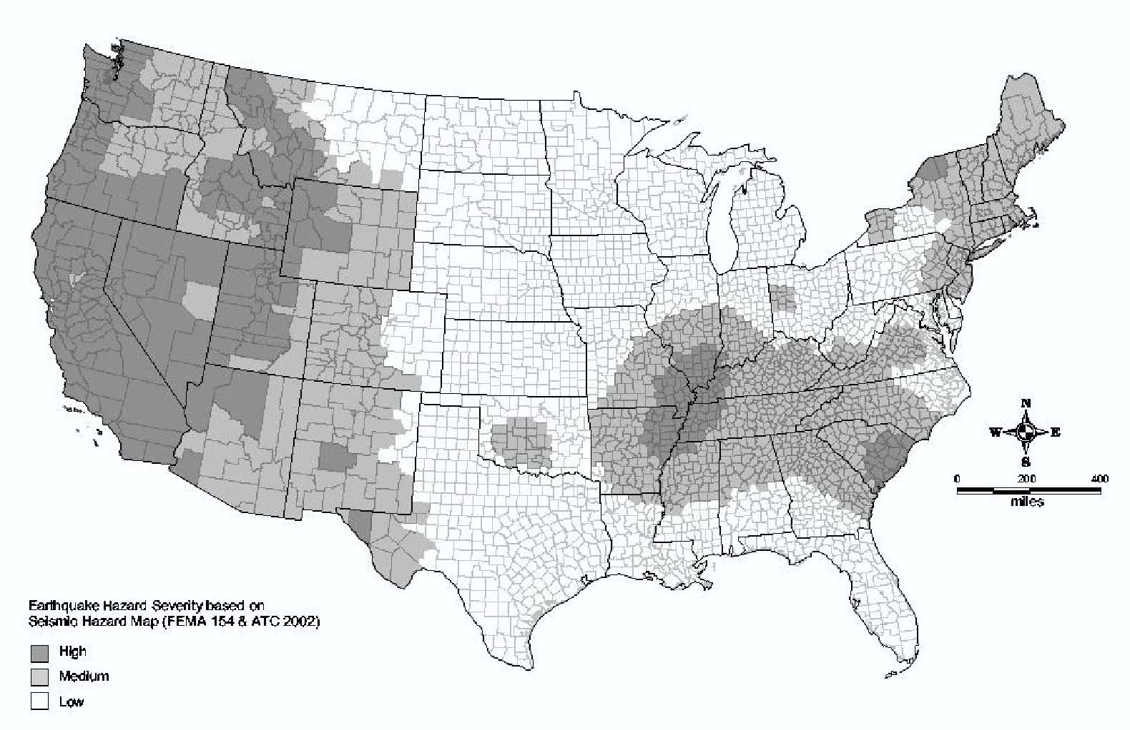

Figure A-1. Hazard Level Map for Earthquake (Source: FEMA, 2002)

High: PGA > 0.5 g
Medium: 0.15≤PGA≤0.5 g
Low: PGA <0.15 g

Figure A-1. Hazard Level Map for Earthquakes (Source: USGS 2002)
Figure A-2. Hazard Level Map for Landslide (Source: USGS 1997a)
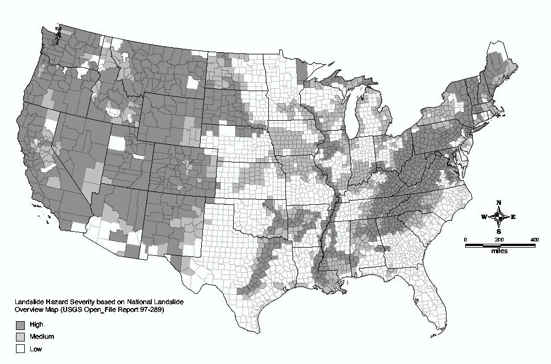
High: Incidence/ SusceptibilityMedium: Incidence or SusceptibilityLow: Incidence
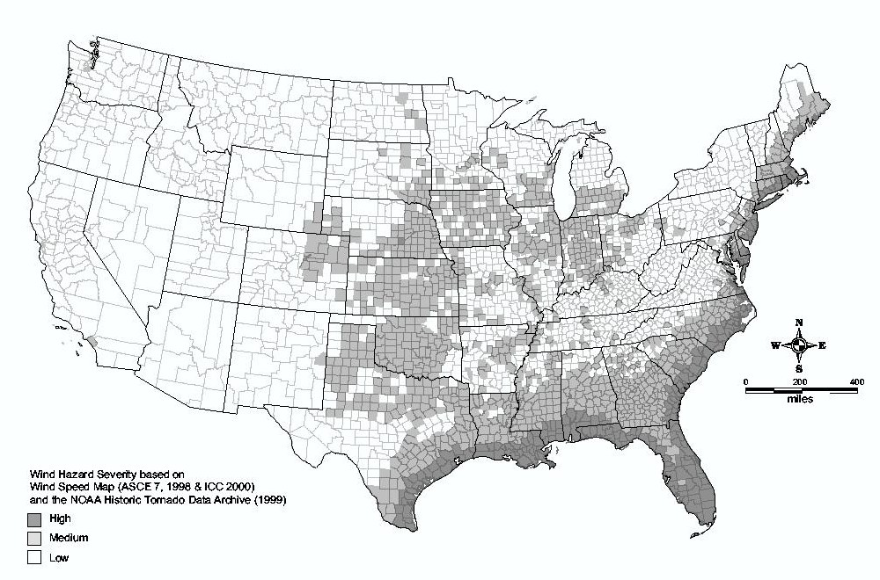
High: Wind Speed ≥ 120 mph
Medium: 90 <Wind Speed <120 mph
Low: Wind Speed < 90 mph

Figure A-3. Hazard Level Map for Severe Wind, Hurricane Wind and Tornado (Sources: ASCE 2005, ICC 2003, NOAA 1999)

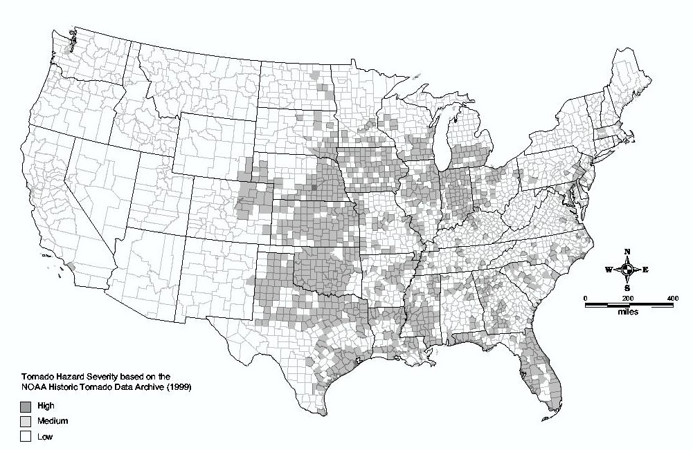
Number per 10⁴ mi²High: > 25 Medium: 5 to 25 Low: < 5

Figure A-4. Hazard Level Map for Tornado Only (Source: NOAA 1999)

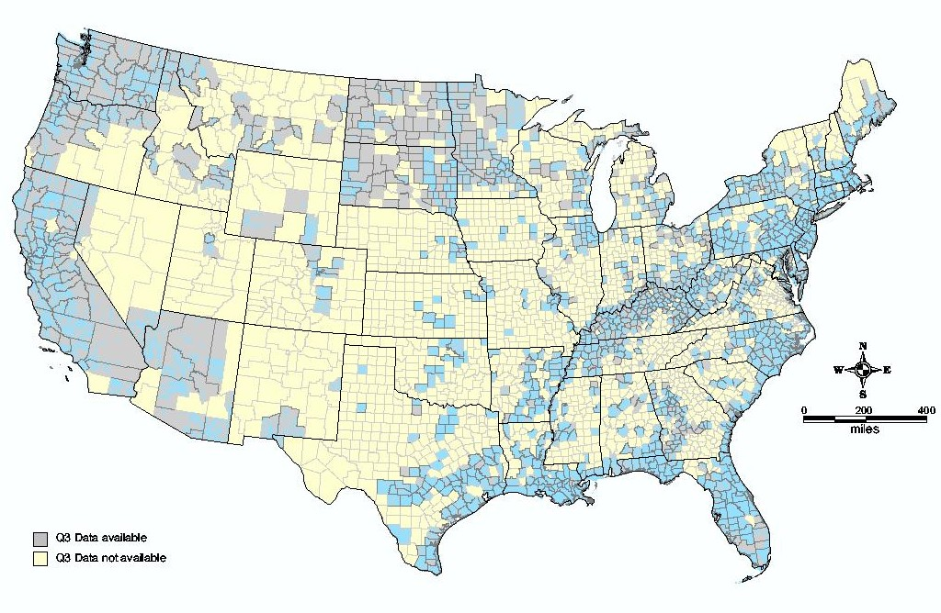
Q3 data available
Q3 data not available

Figure A-5. Hazard Level Map for Riverine and Coastal Flooding (Source: FEMA 2003)

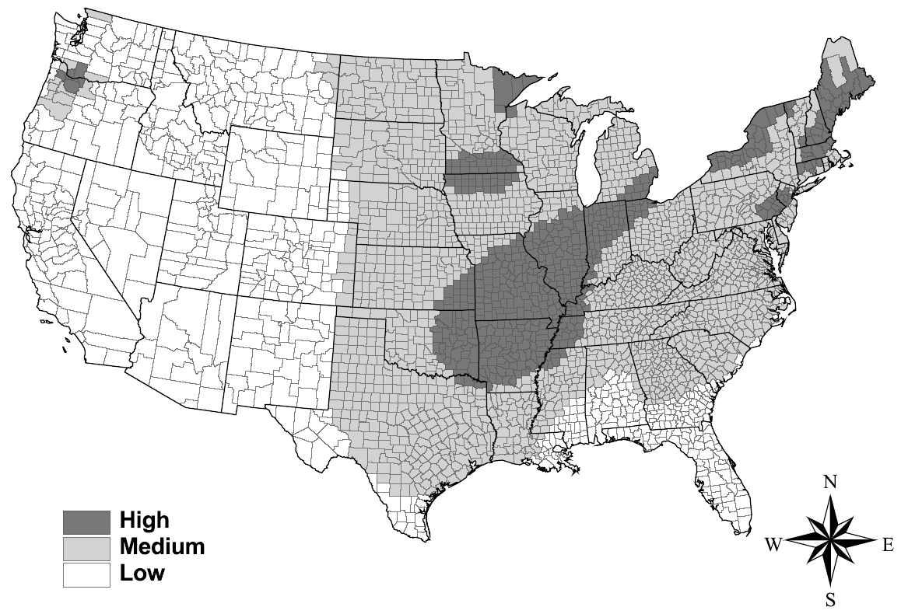
High: Ice Thickness ≥ 1.0 inch
Medium: 0.25 < Ice Thickness <1.0 inches
Low: Ice Thickness < 0.25 inch

Figure A-6. Hazard Level Map for Atmospheric Icing (Source: ALA, 2004)

Appendix B: Examples

Example 1: Inquiry from City Manager to County Water Agency on Potential Service Interruptions
Inquiry: As a result of concerns regarding the insufficient amount of water storage capacity, a City Manager in Maricopa County, Arizona requests the county water agency (CWA) that supplies the city’s water to provide information on the duration and severity of potential interruptions in the supply of water to the city. The CWA provides water to ten other communities that serve a combined population of 250,000.
Assessment: The CWA response to this inquiry is based on understanding the primary reason for this inquiry is to allow plans to be made to assure reliable drinking water supplies. The primary metrics to be used in responding to the City Manager will be the length of potential service outages or reduced water deliveries from the CWA. Water is provided to the city by a single 36-inch transmission pipeline that transports water 25 km to the city from several 1 MG aboveground storage tanks. The city is entitled to delivery of up to 5 MGD, which is 40% of the water supply typically available in storage. The pipeline traverses hilly terrain in the vicinity of the storage tank facility and crosses several stream beds that carry water only during the rainy season.
Step 1: Determine what hazards should be considered in the response and the general vulnerability of the (Phase 1 hazard assessment). From the hazard maps in Appendix A, the following hazard information is extracted:
Seismic hazard = Medium
Landslide hazard = Medium
Severe wind hazard = Low
There is a Q3 flood map available
The Phase 1 screening for human threat hazards considers the following:
- No notices of specific threats to the system have been received in the past 3 years and no attacks on a similar system have ever occurred. Therefore, the hazard is considered Low.
- The fact that the pipelines are buried, the tank farm is gated with a security guard, and damage to a single tank will only impact part of the storage capacity, are considered sufficient to consider the vulnerability to attack as Low.
Step 2: Determine general vulnerability to damage or disruption (Phase 1 vulnerability assessment). The vulnerability matrix in Table 3-2 indicates that storage tanks have a High vulnerability to earthquake ground shaking and ground displacement. The pipelines have Low vulnerability to flooding and a High vulnerability to ground displacement. Because there are natural hazards that are not low and vulnerability levels are high, the user is prompted to proceed to a Phase 2 assessment. Human threats are screened out as not requiring a Phase 2 assessment for this particular inquiry.
Step 3: Determine the hazard rating and score. Based upon the earthquake and landslide hazards being moderate, it is determined that the hazard score is 2.
Step 4: Determine the vulnerability rating and score. Based upon the vulnerability to ground displacement being high for both the tanks and the pipelines, it is determined that the vulnerability score is 3.
Step 5: Determine the operational criticality rating. The usage importance rating, UR, for the tanks and pipelines is taken as 5 based upon assigning a relative potable water importance factor, f_{p}, of 1.0 and a potable water rating score, PR, of 5. The system importance rating, SR, is taken as 5 based upon the city’s usage of 5 MGD. Since UR and SR are both 5, the resulting operational criticality rating, OCR, is 5.
Step 6: Determine the overall rating. Using Equation 4-1 with the hazard, vulnerability, and consequence scores from Steps 3 through 5, the level index is computed to be:
R = H x V x OCR= 2 x 3 x 5 = 30
For a level index (R) of 30, Table 5-2 recommends a Level 2 baseline analysis level for Phase 2, which means an H2-V2-S2 analysis. However, because of the simple nature of the system (single pipeline from storage tanks to city delivery location), the system analysis level is adjusted downwards from S2 to S1.
Step 7: Perform Level 2 Hazard (H2) Analysis. Referring to Table 4-3, an H2 analysis consists of Tasks 1.1 through 2.1 with the exception of tasks 1.1.7, 1.2.13, 1.3.7, 1.3.8, 1.4.10, and 2.1.8. (review available information and provide estimates of hazards using judgment or simple empirical methods)
Step 8: Perform Level 2 Vulnerability (V2) Analysis. Referring to Table 4-4, Level 1 vulnerability analysis consists of all of Tasks 1 except task 1.9; that is, gathering information by interviewing utility personnel, site surveys, drawing reviews, and reviewing past performance of similar construction exposed to similar hazards.
Step 9: Perform Level 1 Systems (S1) Analysis. For a Level 1 systems analysis, Table 4-5 recommends Tasks 1.1, 1.2, and 1.5, which include a review of system maps to determine the location of the pipeline and tanks with respect to potential hazard areas, review of system performance in past (similar) events, and an estimate of system performance in earthquake or landslide events using expert judgment.
Results: Depending on the outcome of the analysis, the CWA will be able to provide estimates of the likelihood of an interruption or lowering of normal water delivery and the likely duration of such reductions in service. If the risk of tank damage or pipeline failure and associated consequences as determined by the performance assessment is judged unacceptable, further assessment using higher levels in the hazard or vulnerability elements may be necessary. A more quantitative and reliable result would be expected for higher analysis levels.

Example 2: Inquiry from Water Utility Board on Recommended Changes in Allocation of Operational Maintenance and Improvement Funds to Address the Findings of a Human Threat Vulnerability Assessment
Inquiry: Based upon the findings of a mandated vulnerability self-assessment, the board of a water utility in Sonoma County, California has asked the engineering department to reassess the funding priority assigned to ongoing and planned maintenance and improvement projects and provide recommendations for any budget modifications prior to a board meeting in 3 weeks.
Assessment: The engineering department response is based upon understanding that additional funds are necessary to simultaneously undertake planned capital improvement projects to reduce earthquake risks and implement recommendations from the human threat vulnerability assessment. The earthquake improvements are specifically directed at upgrading steel storage tanks to withstand ground shaking and to reduce the vulnerability from major human threats primarily related to armed attack and destruction of pipelines and water utility facilities and chemical contamination.
Step 1: Determine what hazards should be considered in the response and the general vulnerability of the (Phase 1 hazard assessment). Considering that the inquiry is directed at a specific known natural hazard and potential human threats, the Phase 1 screening assessment of hazard and focuses only on earthquake hazards which are known to be High.
Step 2: Determine general vulnerability to damage or disruption (Phase 1 vulnerability assessment). The inquiry is directed at a specific known earthquake hazard vulnerability which has been determined to be High.
Step 3: Determine the hazard rating and score. Based upon the earthquake hazards being high, it is determined that the hazard score is 3.
Step 4: Determine the vulnerability rating and score. Based upon the vulnerability to earthquake hazards, it is determined that the vulnerability score is 3.
Step 5: Determine the operational criticality rating. The potential impact of a significant earthquake or the hypothetical human threats on the system and the water utility’s ability to deliver water to its customers are known to be substantial and severe. Therefore, the usage importance rating, UR, and system importance rating, SR, are taken as 5. Since UR and SR are both 5, the resulting operational criticality rating, OCR, is 5.

Step 6: Determine the overall rating. Using Equation 4-1 with the hazard, vulnerability, and consequence scores from Steps 3 through 5, the level index is computed to be:
R = H x V x OCR= 3 x 3 x 5 = 45
For a level index (R) of 35, Table 5-2 recommends a Level 3 baseline analysis level for Phase 2, which means an H3-V3-S3 analysis. This high level of baseline analysis is appropriate considering that a full response to the inquiry would be expected to require quantitative estimates of risks related to the financial health of the utility, the level of post-event service that can be provided to customers, and impacts on public welfare. However, because the board has requested a response to their inquiry within three weeks, the analysis level is adjusted downward from H3-V3-S3 to H1-V1-S1.
Step 7: Perform Level 1 Hazard (H1) Analysis. Referring to Tables 4-3 and 4-6, an H1 analysis consists of Tasks 1.3.1, through 1.3.5 in Table 4-3 and Tasks 1.1.1, 1.1.2, 1.1.5, 1.1.6, and Tasks 1.2.1 through 1.2.3 in Table 4-6. The information for the H1 analysis will be readily available from the human threat vulnerability assessment study and past work to determine the need for seismic tank upgrades.
Step 8: Perform Level 1 Vulnerability (V1) Analysis. A Level 1 vulnerability analysis consists only of Tasks 1.1 and 1.7 in Table 4-4; that is, gathering information by interviewing utility design engineers, field engineers, and operations managers and assessing storage tank fragilities using estimates, informed estimates, and experience data from past events, respectively. The information for the V1 analysis will be readily available from the human threat vulnerability assessment study and past work to determine the need for seismic tank upgrades.
Step 9: Perform Level 1 Systems (S1) Analysis. For a Level 1 systems analysis, Table 4-5 recommends Tasks 1.1, 1.2, and 1.5, which include a review of system maps to determine the location of the pipeline and tanks with respect to potential hazard areas, review of system performance in past (similar) events, and an estimate of system performance in earthquake or landslide events using expert judgment.
Results: The qualitative response to the inquiry should identify that a more complete response would require substantial time and effort and recommend a more detailed analysis if the response based upon a Level 1 analysis is not be sufficient for the board to use in making a determination where priority should be given to distribution of funds.

Example 3: Inquiry from a Regulatory Body Regarding the Performance of a Critical Facility to a Specific Hazard
Inquiry: A water utility has been requested by the Public Utilities Commission to assess the risk of chemical/biological attack on an impounded lake that is the primary source of water.
Assessment: The utility will base its response on how vulnerable it is to the identified threats and what actions are currently being taken to reduce the potential for such an event to occur.
Step 1: Determine the overall rating. As stated Section 3, because human threat events are typically considered to be ever present, the evaluation proceeds directly to a Phase 2 analysis.
Step 2: Determine the hazard rating and score. Because the current threat level is yellow or elevated, the hazard level is assigned a Moderate index and the corresponding hazard rating is 2.
Step 3: Determine the vulnerability rating and score. Table 3-2 indicates that the vulnerability of an open reservoir to chemical or biological attack is Moderate. The corresponding vulnerability rating is 2.
Step 4: Determine the operational criticality rating. The usage importance rating, UR, for the reservoir is taken as 5 based upon assigning a relative potable water importance factor, f_{p}, of 1.0 and a potable water rating score, PR, of 5. The system importance rating, SR, is taken as 5 based upon the fact that the reservoir is the primary source of water to the system. Since UR and SR are both 5, the resulting operational criticality rating, OCR, is 5.
Step 5: Determine the overall rating. Using Equation 4-1 with the hazard, vulnerability, and consequence scores from Steps 3 through 5, the level index is computed to be:
R = H x V x OCR= 2 x 2 x 5 = 20
For a level index (R) of 30, Table 5-2 recommends a Level 2 baseline analysis level for Phase 2, which means an H2-V2-S2 analysis. However, because of the inquiry is directed at a specific component of the system, the system analysis level is adjusted downwards from S2 to S1.
Step 6: Perform Level 2 Hazard (H2) Analysis. Referring to Table 4-6, a Level 2 analysis for chemical or biological attack consists of Tasks 1.1.1 through 1.1.7 (collect data on past incidents and near misses, collect historic data on other companies and industrial systems, review federal and state homeland security agency data, and consult with internal experts, consult with law enforcement agencies).
Step 7: Perform Level 2 Vulnerability (V2) Analysis. Per Table 4-7, a Level 2 vulnerability analysis for chemical or biological attack consists of most tasks under Tasks 1 through 3 (data collection, exposure assessment, and vulnerability assessment).
Step 8: Perform Level 1 System (S1) Analysis. For a Level 1 system analysis, Table 4-8 recommends Tasks 1.1 and 1.4 (contact federal, state, and local agencies and use expert judgment to estimate system performance.)
Results: Depending on the outcome of the analysis, the utility will be able to demonstrate that 1) it has thoroughly assessed the likelihood of anticipated threats, 2) it has identified measures that can be taken to prevent or mitigate the impacts of the event should the event occur, or 3) further assessment is necessary to fully quantify the magnitude of the threat and steps to reduce the risks from the threat to a level that is as low as reasonably achievable.

Example 4: Inquiry by a Public Official – Consequence of a Local Hazard at a Well Field
Inquiry: A state official has reviewed water system maps and determined that a specific well field that provides up to 3,000 gpm of supplemental water that the utility provides to a large city in coastal Mississippi. He queries the water utility on the system performance consequences of inundation of this well field should a hurricane lead to breaching of a levy adjacent to the well field based upon recently revised estimates of possible levels of hurricane-related storm surge.
Assessment: The water utility will base its response on three factors: 1) the credibility of the analysis that identifies the likelihood of levy breach, 2) the present vulnerability of the well field to flooding, and 3) the overall impacts on the system performance should the well field be compromised as a result of flooding.
Step 1: Determine the hazard rating and score. From the flood hazard map in Appendix A, Q3 maps are available for all of coastal Mississippi leading to a High hazard rating Furthermore, the inquiry itself indicates a newly discovered flooding threat. The hazard score for a High rating is 3.
Step 2: Determine general vulnerability to damage or disruption (Phase 1 assessment). The vulnerability matrix in Table 3-2 indicates that wells have a Moderate vulnerability to flooding hazards. The corresponding vulnerability score is 2. Because, neither the hazard rating nor vulnerability rating are Low, a Phase 2 analysis is necessary.
Step 3: Determine the operational criticality rating. The usage importance rating, UR, for the reservoir is determined as follows:
- Personnel are located at the well field less than 20% of the time (life safety rating, LR, of 1)
- The well field provides less than 20% of the potable water to the city (potable water rating, PR, of 2)
- The potable water and life safety factors, f_{p}, and f_{l}, respectively, are judged to be 0.8 and 0.2, respectively.
- The resulting usage importance rating, UR, is determined by Equation 4-3:
UR = 0.8(2) + 0.2(1) = 1.8 (assigned a value of 2)
- The well field capacity is less than 5,000 gpm (system importance rating, SR, of 3)
- The relative system importance and usage importance factors, f_{s}, and f_{u}, respectively, are judged to be 0.2 and 0.8, respectively. The resulting operational criticality rating, OCR, is determined by Equation 4-2:
OCR = 0.2(3) + 0.8(2) = 2.2 (assigned a value of 2)
Step 4: Determine the overall rating. Using Equation 4-1 with the hazard, vulnerability, and consequence scores from Steps 1 through 3, the level index is computed to be:
R = H x V x OCR= 3 x 2 x 2 = 12
For a level index (R) of 12, Table 4-1 recommends a Level 1 baseline analysis level for Phase 2, which means an H1-V1-S1 analysis.
Step 5: Perform Level 1 Hazard (H1) Analysis. Referring to Table 4-3, an H1 analysis for flooding effects consists of Tasks 5.1, 5.2, 5.6 and 5.7 (review of flood maps and flood data and evaluate using expert judgment).
Step 6: Perform Level 1 Vulnerability (V1) Analysis. Per Table 4-4, a Level 1 vulnerability analysis for electric power equipment consists of Tasks 1.1 and 1.7 (gather information from interviews and site surveys on local conditions to assess possible collateral hazards, assess equipment fragilities using expert judgment and past experience).
Step 7: Perform Level 1 System (S1) Analysis. For a Level 1 systems analysis, Table 5-6 recommends Tasks 1.1, 1.2, and 1.5 (review system maps, review system performance in past events, and evaluate system performance using expert judgment).
Results: Depending on the outcome, the utility will be able to 1) confirm the likelihood for the well field will being subjected to flooding as a result of levy overtopping, 2) determine the ability of the current design and construction measures to function during or immediately following a flooding event, 3) indicate whether or not more detailed information or analysis (e.g., Level 2) is required before responding to the inquiry, or 4) indicate what actions will be taken to mitigate damage from the new flooding threat.

Labor requirements are measured by the time required for one person working full time to complete the study. More details on this assignment are provided in Section 4.6.
This term is used to reflect the best accuracy possible given current, accepted technologies and analysis capabilities.

